**GUARDIAN ANGELS: HARNESSING RFID FOR ENHANCED SECURITY AND EFFICIENCY IN NEW-BORN CARE.**

**CARL BRANDON VALENTINE**

**FACULTY OF COMPUTING AND INFORMATICS**

**UNIVERSITY MALAYSIA SABAH 2024**

**GUARDIAN ANGELS: HARNESSING RFID FOR ENHANCED SECURITY AND EFFICIENCY IN NEW-BORN CARE.**

**CARL BRANDON VALENTINE**

**THESIS SUBMITTED IN PARTIAL FULFILLMENT FOR THE DEGREE OF BACHELOR OF COMPUTER SCIENCE WITH HONOURS**

**(SOFTWARE ENGINEERING)**

**NAME :** CARL BRANDON VALENTINE

**MATRICS NUMBER :** BI21160464

**TITLE :** GUARDIAN ANGELS: HARNESSING RFID FOR ENHANCED SECURITY AND EFFICIENCY IN NEW-BORN CARE.

**DEGREE :** BACHELOR OF COMPUTER SCIENCE WITH HONOR (SOFTWARE ENGINEERING)

### VIVA’S DATE : 1 JULY 2024

**CERTIFIED BY;**

### 1. SUPERVISOR Signature

**Ts. Dr. Khalifa Chekima**

# DECLARATION

I hereby declare that the material in this thesis is my own except for quotations, equations, summaries and references, which have been duly acknowledged.

27 APRIL 2024

CARL BRANDON VALENTINE BI21160464

# ACKNOWLEDGEMENT

Immense gratitude to my supervisor, Ts Dr Khalifa Chekima for steadfast guidance and invaluable insights. I thank my family and friends for their enduring support and encouragement. My deepest appreciation goes to the divine for faith and perseverance, and I acknowledge my own relentless dedication that fuelled this endeavour

# ABSTRACT

This project, introduces an innovative Radio-Frequency Identification (RFID) system designed to enhance new born security in hospital settings. The objective was to develop a reliable and efficient method for monitoring and managing the care of new born. Following the Iterative Software Development Life Cycle (SDLC) model, the project involved multiple development cycles, each including phases of planning, design, implementation, and evaluation. A prototype was constructed, consisting of RFID tags and readers paired with a web dashboard for real-time tracking and data analysis. The prototype was iteratively refined based on feedback from simulated testing environments. The results demonstrated improved accuracy in new born tracking and streamlined operations in neonatal care. The study concludes that implementing such RFID systems could significantly bolster hospital security protocols and provide a safer environment for infant care. Future work suggests exploring the integration of this technology with wider hospital management systems and extending its application to other vulnerable patient groups.

**ABSTRAK**

**GUARDIAN ANGELS: MEMANFAATKAN RFID UNTUK MENINGKATKAN KESELAMATAN DAN KECEKAPAN DALAM PENJAGAAN BAYI BARU LAHIR**

Projek ini, memperkenalkan sistem Pengenalan Frekuensi Radio (RFID) inovatif yang direka untuk meningkatkan keselamatan bayi baru lahir dalam tetapan hospital. Objektifnya adalah untuk membangunkan kaedah yang boleh dipercayai dan cekap untuk memantau dan mengurus penjagaan bayi baru lahir. Mengikuti model Kitaran Hayat Pembangunan Perisian Berulang (SDLC), projek itu melibatkan pelbagai kitaran pembangunan, setiap satu termasuk fasa perancangan, reka bentuk, pelaksanaan dan penilaian. Satu prototaip telah dibina, yang terdiri daripada teg RFID dan pembaca yang dipasangkan dengan papan pemuka web untuk penjejakan masa nyata dan analisis data. Prototaip telah diperhalusi secara berulang berdasarkan maklum balas daripada persekitaran ujian simulasi. Hasilnya menunjukkan ketepatan yang lebih baik dalam pengesanan bayi baru lahir dan operasi yang diperkemas dalam penjagaan neonatal. Kajian itu menyimpulkan bahawa melaksanakan sistem RFID sebegini boleh meningkatkan protokol keselamatan hospital dengan ketara dan menyediakan persekitaran yang lebih selamat untuk penjagaan bayi. Kerja masa depan mencadangkan meneroka integrasi teknologi ini dengan sistem pengurusan hospital yang lebih luas dan memperluaskan aplikasinya kepada kumpulan pesakit lain yang terdedah.

# TABLE OF CONTENTS

**Title Page**

DECLARATION *iii*

ACKNOWLEDGEMENT *iv*

ABSTRACT *v*

ABSTRAK *vi*

TABLE OF CONTENTS *vii*

LIST OF TABLES *ix*

CHAPTER 1 *2*

* 1. Introduction 2
  2. Problem Background 3
  3. Problem Statement 4
  4. Objectives 4
  5. Project Scope 5
     1. Main Goal 5
     2. Target User 5
     3. Potential Stakeholders 5
     4. Modules 6
  6. Expected Outcome 8
  7. Project Schedule 8
  8. Organization of the Report 8

CHAPTER 2 *2*

* 1. Introduction 2
  2. Evolution of RFID Technology in Healthcare 2
  3. Applications of RFID In New Born Care 11
  4. Current Trends and Future Prospects for RFID in Healthcare 12
  5. Review of Similar Systems 13
     1. Systems Compared 13
     2. Comparison Tables of Existing Systems 14
     3. Discussion 16
     4. Conclusion 16
  6. Hardware for Guardian Angel Prototype 17
     1. Hardware Components 17
  7. System Integration and Functionality 19
  8. Conclusion 20

CHAPTER 3 *9*

* 1. Introduction 9
  2. Iterative Model Overview 22
  3. Phase Description 23
     1. Planning Phase 23
     2. Design Phase 23
     3. Implementation Phase 24
     4. Evaluation Phase 24
  4. Flow Chart of Activity 25
  5. Milestone and Date 25
  6. Gantt Chart 26

CHAPTER 4 *27*

SYSTEM ANALYSIS AND DESIGN *27*

* 1. Introduction 27
  2. System Analysis 27
     1. Document Analysis 28
     2. Questionnaires 30
  3. System Design. 33
     1. Use Case Diagram 34
     2. Use case Description 34

4.3.4 Data Flow Diagram Level 1 44

4.3.4 Entity-Relationship Diagram 47

* 1. Data Dictionary 47
  2. System Architecture 52
  3. User Interface and Design 53

REFERENCES *58*

APPENDICES *61*

# LIST OF TABLES

|  |  |  |  |
| --- | --- | --- | --- |
|  | | | Page |
| Table 1.1 | : | Table of Modules and Descriptions | 6 |
| Table 2.1 | : | Comparison of Existing Systems | 14 |
| Table 3.1 | : | Milestone and Date | 25 |
| Table 4.1 | : | Use Case Description – Register Mother | 34 |
| Table 4.2 | : | Use Case Description – Register Infant | 35 |
| Table 4.3 | ; | Use Case Description – Assign RFID Tag to Infant | 36 |
| Table 4.4 | : | Use Case Description – Enter Medication Details | 37 |
| Table 4.5 | : | Use Case Description – Generate Alerts | 37 |
| Table 4.6 | : | Use Case Description – Monitor Infant Location | 37 |
| Table 4.7 | : | Use Case Description – Track Log | 38 |
| Table 4.8 | : | Use Case Description – View Dashboard | 39 |
| Table 4.9 | : | Use Case Description – Hardware Connection | 39 |
| Table 4.10 | : | Use Case Description – Print Report | 40 |
| Table 4.11 | : | Use Case Description – Push Medication Notification | 41 |
| Table 4.12 | : | Data Dictionary for Users Table | 47 |
| Table 4.13 | : | Data Dictionary for Mother Table | 48 |
| Table 4.14 | : | Data Dictionary for Newborn Table | 48 |
| Table 4.15 | : | Data Dictionary for Tags Table | 49 |
| Table 4.16 | : | Data Dictionary for RFID Reader Table | 49 |
| Table 4.17 | : | Data Dictionary for Tracking Log Table | 49 |
| Table 4.18 | : | Data Dictionary for History Table | 50 |
| Table 4.19 | : | Data Dictionary for Medication Table | 50 |
| Table 4.20 | : | Data Dictionary for Alert Table | 51 |

**LIST OF FIGURES**

|  |  |  |
| --- | --- | --- |
| Figure 2.1 : | B-Tag&Track on mother and child | Page  14 |
| Figure 2.2 : | Passsive RFID Tag | 17 |
| Figure 2.3 : | RFID Reader | 18 |
| Figure 2.4 : | Raspberry Pi Pico | 19 |
| Figure 2.5 **:** | Raspberry Pi Pico and RFID Reader Circuit | 19 |
| Figure 3.1 **:** | Flow Chart of Activity | 25 |
| Figure 4.1 : | Methods currently used to identify newborn | 31 |
| Figure 4.2 : | Effectiveness of current system in preventing | 32 |
| Figure 4.3 : | Most common case of misidentification | 32 |
| Figure 4.4 : | Challenges ensuring accurate modification | 33 |
| Figure 4.5 : | administration in newborn  System architecture of Guardian Angel | 52 |
| Figure 4.6 : | Login Page | 53 |

# LIST OF ABBREVIATIONS

**RFID** - Radio-Frequency Identification **SDLC** - Software Development Life Cycle **UHF** - Ultra High Frequency

**GPIO** - General Purpose Input/Output

**RP2040** - Raspberry Pi Pico Microcontroller Chip

**IoT** - Internet of Things

**AI** - Artificial Intelligence

# CHAPTER 1

**INTRODUCTION**

### Introduction

The safety and well-being of new born in health care facilities are major concerns, requiring greater tracking and monitoring techniques. Current figures underscore the importance of this issue: the National Centre for Missing & Exploited Children reported 337 confirmed cases of new born abductions in healthcare settings across the United States between 1964 and August 2022, with nearly half taking place in hospitals. Medication errors impair patient safety, affecting an estimated 1.3 million people in the United States each year, according to the World Health Organisation. The Malaysian Ministry of Health has identified pharmaceutical errors as a key issue, emphasising the need for new solutions.

The "Guardian Angels" project presents an implementation of Radio Frequency Identification (RFID) technology to address these fundamental issues. This idea proposes the creation of an RFID-based system to improve infant security and streamline hospital operations. The solution is expected to help healthcare providers provide safe and attentive care by improving tracking capabilities and managing data more efficiently.

This research will look into how RFID technology can help reduce the risk of new born abduction and prescription errors. "Guardian Angels" aspires to positively contribute to existing new born care procedures by developing an interface that is user-friendly and employs excellent data management mechanisms. This introduction is followed by a full overview of the project's problem background, aims, and scope, which serves as context for the creative modules that will make up the proposed system.

### Problem Background

Monitoring and management systems for new born care must be both effective and secure. Traditional tracking methods, which are mostly based on manual procedures, have shown serious flaws that could jeopardise patient safety. These include frequent human errors in patient identification, slow response times in emergency situations, and the inability to track the real-time location and status of patients and medical assets all of which jeopardise the quality of care while also increasing the risk of critical safety incidents.

RFID technology emerges as a possible answer to these issues, offering a more efficient and improve accuracy approach to patient and drug management (ASHP Foundation, 2022). Recent study has focused on the present trends and limitations of RFID in healthcare. These limitations include the high cost of system integration, signal interference difficulties that may impair data accuracy, and the complexity of integrating RFID devices with existing hospital IT infrastructures (RFID Journal, 2021). Despite these challenges, RFID's ability to alter point-of-care services is especially remarkable, it allows for real-time data sharing and asset management, leading in faster and more effective patient care (Eddy, 2023). Furthermore, RFID's ability to foster a seamless, error-free healthcare environment is acknowledged, emphasising the technology's growing applications and vital significance in future healthcare breakthroughs.

Despite the potential of RFID technology, its application in healthcare faces significant challenges. Addressing these challenges is crucial to unlocking RFID's full promise for enhancing new born care. The high costs and technical challenges can be reduced by strategic planning, staggered implementations, and selecting the proper technology partners who provide scalable and integrable solutions. By tackling these difficulties, the "Guardian Angels" effort hopes to not only lower the risks associated with traditional new born care procedures, but also improve overall care delivery efficiency and efficacy by exploiting RFID's expanded capabilities. The use of RFID technology has the potential to transform the standard of care provided in neonatal units by prioritising safety and efficiency in healthcare service delivery.

### Problem Statement

In the critical realm of healthcare, ensuring the safety and well-being of new born is a paramount concern. Traditional methods for monitoring and tracking new born within hospital premises are not only inefficient but also prone to significant errors. This inefficiency is highlighted by the persisting issue of infant abductions in healthcare settings, underscoring the dire consequences of inadequate security measures. Such incidents starkly illustrate the global need for more secure and reliable identification and tracking systems.

Additionally, the healthcare sector faces a grave concern regarding medication errors. These errors represent a major global health risk, significantly impacting patient safety and causing harm on a large scale. The recurring instances of these errors amplify the call for enhanced technological solutions to ensure accurate medication delivery and patient monitoring.

The "Guardian Angels" project addresses these issues by proposing the implementation of Radio Frequency Identification (RFID) technology. This initiative aims to drastically improve the security and accuracy of new born care practices, providing a reliable solution to prevent abductions and reduce medication errors, thereby safeguarding the health and safety of the most vulnerable patients.

### Objectives

Maintaining the greatest levels of safety and efficiency in new born care is crucial. The "Guardian Angels" initiative proposes to use Radio Frequency Identification (RFID) technology to address major issues such as misidentification, new born abduction, and prescription problems in hospital settings. Three set objectives enable the successful deployment of this unique technology:

* + 1. To design a RFID system prototype tailored for new born care, focusing on a user-friendly interface by developing an initial system design that incorporates user-friendly interfaces for both healthcare providers and administrators.
    2. To implement the designed RFID system in a simulated hospital environment using Raspberry Pi Pico, RFID tags, and readers.
    3. To conduct tests within the simulated environment to evaluate the RFID system's performance by using User Acceptance Testing (UAT).

### Project Scope

The RFID-Based New born Care System is designed to enhance safety and improve the management of new born care in hospital settings by integrating advanced RFID technology. This system ensures real-time tracking and efficient management of both new born and healthcare resources, contributing to higher security and operational efficiency.

### Main Goal

The main goal of this project is to enhance new born security, streamline hospital operations, and reduce medication errors through RFID technology. This system aims to improve the accuracy of tracking, efficient data management, and seamless integration of care processes, ensuring a safer environment for new born care.

### Target User

The system's target users include healthcare workers, such as nurses and doctors, who are directly involved in new born care and require reliable, real- time data to improve patient care. The system is also useful for hospital administrators, who may use it to better manage resources and oversee operations. Furthermore, IT and security workers are critical users, responsible for maintaining the system's functioning and protecting sensitive data from breaches.

### Potential Stakeholders

## The project also takes into account a diverse set of possible stakeholders with an interest in the system's success. Families of new born are the major stakeholders, deeply worried about their infants' safety and well-being and

relying on the system for peace of mind. Hospital management teams prioritise the system's potential to improve efficiency and patient care quality, both of which are critical to the hospital's operational success. Furthermore, RFID technology providers are stakeholders who care about the robust deployment and performance of their products in the healthcare environment. Finally, healthcare policymakers may use system insights and data to impact broader healthcare policies and efforts related to neonatal care and medical technology use.

### Modules

The system includes several modules, each tailored to meet the needs of the hospital's new born care unit:

### Table 1.1 : Table of Modules and Descriptions

|  |  |
| --- | --- |
| **Module Name** | **Description** |
| Mother and Infant Registration and Identification Module | This module allows medical personnel to register mothers and newborns into the system. It captures essential details such as names, birthdates, blood types, and other relevant information. Each mother and infant pair is linked for accurate record-keeping and  identification. |
| Tracking Module | This module tracks the location of infants within the hospital using RFID tags. RFID readers placed at strategic points, such as room exits, detect and log the movements of tagged infants. This ensures real-time monitoring and  enhances infant safety. |
| Medication Administration Module | This module manages and tracks the administration of medications to infants. Medical personnel can input medication details,  including dosages and schedules, ensuring |

|  |  |
| --- | --- |
|  | precise and timely administration. The module  also records administration events for future reference. |
| Alerts and Notifications Module | This module handles the generation and management of alerts and notifications. It provides real-time alerts when an infant exits a designated area or when medication is due.  Notifications are designed to ensure timely responses from medical personnel. |
| Dashboard Module | The dashboard module offers a user-friendly interface for medical personnel to view real-  time data and notifications. It provides a consolidated view of alerts, infant locations, medication schedules, and other critical information, enabling efficient monitoring and  decision-making. |
| Report Module | The report module allows for the generation of various reports based on the data collected by the system. Administrators can create reports on infant movements, medication administration, and system alerts. These reports are essential for analysis, auditing, and  compliance purposes. |
| Hardware Management Module | This module monitors the status of all hardware components within the system, including RFID readers and the Raspberry Pi. It displays real- time connectivity status and logs any issues or errors, ensuring that the system operates  smoothly. |
| System Administration Module | The system administration module provides administrative functionalities for overseeing all other modules. Administrators can manage user accounts, set system configurations, and ensure the overall security and integrity of the  system. |

### Expected Outcome

The successful implementation of the “Guardian Angel” is predicted to result in a considerable improvement in the hospital's new born care safety and efficiency. The system will improve accuracy in new born tracking and management, reduce the risk of medical errors, and improve operational workflow, resulting in better patient care and greater satisfaction among healthcare providers and family members.

### Project Schedule

This section outlines the project schedule depicted through a Gantt chart in Appendix A, adhering to an Iterative SDLC model. The process cycles through planning, analysis, design, implementation, and testing, refining with each iteration. Project initiation is on May 1, 2024, with three development iterations followed by a deployment phase, aiming for project completion by January 1, 2025**.**

### Organization of the Report

This report outlines the development of the "Guardian Angels" RFID system. It begins with an introduction to the project's purpose and significance. Subsequent chapters discuss the Iterative SDLC model used for development, the construction of the RFID system and web dashboard, and iterative testing phases. The final sections analyse the results, draw conclusions, and suggest directions for future research. Appendices provide supporting documents and the detailed project Gantt chart

# CHAPTER 2

**LITERATURE REVIEW**

### Introduction

This literature study focuses at the use of Radio Frequency Identification (RFID) technology in healthcare, with an emphasis on new born care applications. It evaluates how RFID has been used to improve patient safety and operational efficiency while addressing obstacles and gaps in current research. This review will help to shape the "Guardian Angels" initiative by contextualising RFID within the unique needs of new born care, while also aligning with worldwide norms and technical improvements. The findings will inform the project's design and execution tactics, assuring relevance and efficacy in enhancing new born care environments.

### Evolution of RFID Technology in Healthcare

Originally created to identify friendly aircraft during World War II, Radio Frequency Identification (RFID) technology has its origins in that conflict. According to Zulkifli, Zainal and Wahap (2020), this early application paved the way for RFID's acceptance in a variety of industries by emphasizing the technology's potential for unique identification capabilities without requiring direct line-of-sight. The introduction of RFID technology into the healthcare industry did not occur until the late 1990s, which signalled a significant change from tracking in general to vital uses such pharmaceutical logistics and patient management (“RFID Technology in Healthcare: Benefits, Challenges, Opportunities”, 2020).

Considerable progress has been made in RFID technology along its evolution. At first, advancements were concentrated on expanding the RFID tags' signal range, storing capacity, and physical dimensions in order to make them more appropriate for delicate uses like patient monitoring (Cenango, 2022). Real-time data transfer

and continuous patient monitoring features critical for contemporary healthcare settings have been made possible by RFID's integration with emerging technologies, such as wireless communication networks and more recently, the Internet of Things (IoT) (Wong, 2021).

Medical equipment tracking and pharmaceutical inventory management were the first uses of RFID in the healthcare industry, and they were critical in lowering errors and increasing operational effectiveness (Wong, 2021). The uses of RFID technology increased dramatically as it developed. Pratt Regional Medical Centre was one of the first hospitals to use RFID technology. Its systems improved new born security by making sure infants weren't mismatched or removed from maternity wards (Wong, 2021).

RFID technology has had a significant influence on new born care. Neonatal unit safety standards have been improved by the use of systems like the Hugs Infant Protection Solution, which are made especially for these needs. These technologies use RFID to track new born locations in real time, pair babies with their parents automatically, and make sure every baby is secure and accounted for (Wong, 2021). These examples highlight how RFID might help with the particular difficulties faced by neonatal care settings, where it is important to reduce the possibility of human error in order to protect the young, defenceless infants.

With advances like biocompatible tags for patient monitoring and smart healthcare systems that combine RFID data inputs with diagnostic instruments, RFID technology is expected to continue to advance in the future (“RFID Technology in Healthcare: Benefits, Challenges, Opportunities”, 2020). By offering more complete care solutions and enabling sophisticated data analytics for enhanced decision- making, these developments hold the potential to further improve the effectiveness of RFID applications in healthcare.

To sum up, the development of RFID from a crude identifying tool to a key component of healthcare innovation is a prime example of how rapidly technology is evolving to meet complicated problems. As RFID technology advances, there is still a significant chance that it may transform new born care and other healthcare

applications, necessitating further study and development (“RFID Technology in Healthcare: Benefits, Challenges, Opportunities”, 2020); Wong, 2021).

### Applications of RFID In New Born Care

RFID technology has become a key to improving safety and operational efficiency in infant care units, ensuring accurate identification and continuous tracking of new born. Hugs Infant Protection Solution and other systems automate the process of matching new born with their mothers, considerably minimizing human error. Such measures are critical in preventing infant swaps and unlawful withdrawals from the unit (Wong, 2021).

A significant application of RFID in infant care is to reduce medication errors, which are common in neonatal units due to the difficulties of dosing and giving medications to such vulnerable babies. Medication errors can happen at any phase in the medication-use process, including prescribing, dispensing, and administering. These errors become worse by the frequent requirement for drug dilutions and calculations, which raises the risk of potentially catastrophic dose mistakes.

RFID technology can help alleviate these issues by ensuring that vital medication information is easily accessible and accurate. RFID tags can record important data such as drug dosages, timetables, and patient information, which healthcare personnel can retrieve instantaneously at the point of service. This capability helps to guarantee that babies receive the proper drugs, considerably lowering the likelihood of errors. Furthermore, RFID systems can be integrated with electronic medical records and pharmacy information systems, offering a comprehensive perspective of a patient's medication history and present needs, hence reducing errors (Wong, 2021).

The advantages of RFID in new born care go beyond medication safety. These technologies improve overall safety by tracking locations in real time, operating efficiency by minimizing human inspections, and medical record accuracy. Furthermore, RFID technology reduces important issues such as child abduction by providing systems with alarms that sound when a new born is taken near an exit

without proper authority. RFID technologies' automated nature reduces human error in the frenetic atmosphere of new born units by substituting error-prone manual processes with dependable automation (Wong, 2021).

RFID's future in new born care seems promising, with possible synergies with emerging technologies like the Internet of Things (IoT) and artificial intelligence (AI) to improve care even further. These developments could lead to RFID systems equipped with sensors for monitoring vital signs, allowing for the detection of health issues before they become serious, paving the door for a new level of precision in new born monitoring (Wong, 2021).

As RFID technology advances, its ability to transform neonatal care practices emphasizes the necessity of ongoing research and technological innovation in this area. RFID integration could be a vital component in a larger plan to reduce medication errors in neonatal care, stressing the importance of holistic solutions to this chronic problem.

### Current Trends and Future Prospects for RFID in Healthcare

The landscape of RFID technology in healthcare is changing dramatically, driven by recent breakthroughs and integration with other cutting-edge technologies. RFID technological advancements have resulted in the development of smaller, more efficient tags with improved data storage capabilities, allowing for a greater range of healthcare applications (Profetto, L., Gherardelli, M., & Iadanza, 2022). A notable trend is the integration of RFID and the Internet of Things (IoT), which is paving the way for smart healthcare solutions capable of providing full treatment via interconnected devices. Artificial intelligence (AI) and machine learning are also being coupled with RFID devices, with the potential to transform data analysis and patient monitoring through predictive analytics and real-time decision-making (“RFID Technology in Healthcare: Benefits, Challenges, Opportunities”, 2020).

Looking ahead, these technological linkages are predicted to improve new born care by enabling enhanced monitoring systems that can follow vital signs and identify movements, potentially alerting carers to problems before they become

critical (Eddy, N., 2023). However, the road to potential prospective uses is not without challenges. The adoption of such sophisticated systems must overcome technological barriers, legal hurdles, and ethical issues in order to fully realise the benefits of RFID technology while protecting patient safety and privacy.

As technology advances, the healthcare industry is about to see a paradigm shift in how treatment is delivered, particularly to the most vulnerable patients, such as infants. RFID technology has enormous promise for improving care quality and efficiency, and with further innovation and appropriate application, it will play an important role in determining the future of healthcare services (Profetto, L., Gherardelli, M., & Iadanza, 2022).

### Review of Similar Systems

The implementation of RFID technology into new born care systems has numerous advantages, including improved monitoring, safety, and operational efficiency. This section compares the proposed RFID-Based New born Care System to similar systems described in the literature, highlighting differences and potential improvements.

### Systems Compared

Northwestern University and Ann & Robert H. Lurie Children's Hospital of Chicago's most recent version of wireless sensors - This system uses wireless sensor technology rather than RFID but shares common goals in monitoring and improving new born care.

1. Pratt Regional Medical Center’s RFID System

A direct application of RFID technology for newborn security, similar to the proposed system.

1. B-Tag&Track® System in Malaysia

An RFID-based system that tracks both mothers and new born, offering a close comparison to the proposed project.

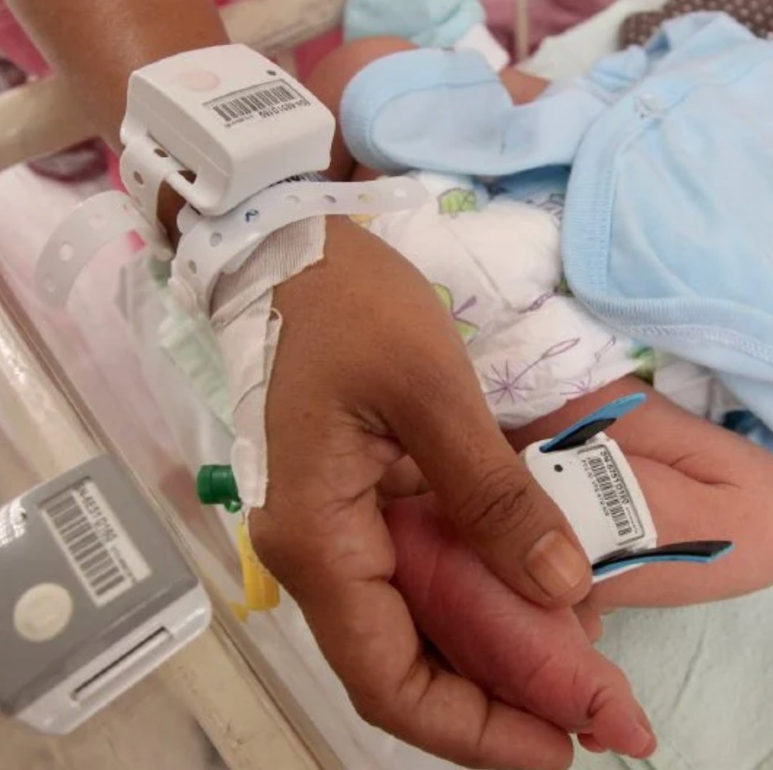

### Figure 2.1 : B-Tag&Track’s Tag on mother and child

Source : https://shorturl.at/sMN36

### Comparison Tables of Existing Systems

**Table 2.1 : Comparison of Existing Systems**

|  |  |  |  |  |
| --- | --- | --- | --- | --- |
| **Feature/ Criteria** | **Northwestern University and Ann & Robert H. Lurie Children's Hospital of**  **Chicago's** | **Pratt Regional Medical Center’s RFID System** | **B-Tag&Track® System** | **GUARDIAN ANGEL** |
| Technology  Used | Wireless  sensors | RFID | RFID | RFID |
| Primary Objectives | Enhance new born care,  increase | Prevent new born  abduction, | Real-time tracking and  monitoring of | Enhance security and  efficiency in |

|  |  |  |  |  |
| --- | --- | --- | --- | --- |
|  | parent-infant interaction (Northwestern University and Ann & Robert  H. Lurie Children’s Hospital of  Chicago, 2020) | ensure infant- mother matching (Wong,2021) | mothers and new born (Zuilkifli,Zainal & Wahap, 2020) | new born care |
| Key Feature | Battery- charged, flexible sensors, allows skin-to-skin contact | Real-time location tracking, automated alerts, infant- mother matching (Wong,2021) | Real-time location tracking, infant- mother matching, monitoring in public hospital settings (Zuilkifli,Zainal &  Wahap, 2020) | Real-time tracking, automated alerts, data integration with hospital systems |
| Observed Benefits | More clinical data collection, better parent- infant bonding | Increased new born security, reduced risk of abduction (Wong,2021) | Improved hospital workflow, increased safety for mother and new born (Zuilkifli,Zainal &  Wahap, 2020) | Potential for enhanced new born safety, operational efficiency |
| Integration with Hospital Systems | Not specified | Integrated with existing Cisco wireless network (Wong,2021) | Integrated with hospital information systems (Zuilkifli,Zainal &  Wahap, 2020) | Planned integration with hospital information  systems |

|  |  |  |  |  |
| --- | --- | --- | --- | --- |
| Challenges/ Drawbacks | Limited to non- RFID  technology | Dependent on network infrastructure (Wong,2021) | High initial implementation cost (Zuilkifli,Zainal &  Wahap, 2020) | Limited to RFID  technology |

### Discussion

“Northwestern University and Ann & Robert H. Lurie Children's Hospital of Chicago's most recent version of wireless sensors” provides critical insights into the benefits of improving physical contact between parents and new born, which could inform additional features in RFID systems to reduce the intrusive nature of monitoring devices.

“The Pratt Regional Medical Center's RFID System” is directly aligned with the proposed system's aims, particularly those concerning security. It demonstrates RFID's usefulness in preventing new born abductions, which is also a key component of the proposed system. This comparison demonstrates the potential for the proposed system to go beyond security and include broader healthcare applications like health monitoring.

“The B-Tag&Track® System” is the closest comparison, as it uses RFID technology in a similar hospital setting. It gives a solid example of system integration with hospital operations, which is an important component of the proposed system. “The B-Tag&Track® System's” implementation in a public hospital teaches essential lessons about scalability and public sector applicability, which are relevant to the proposed system's deployment approach.

### Conclusion

This comparison illustrates that, while there are multiple systems with comparable goals, the proposed “Guardian Angel” combines the capabilities of current systems while also introducing new functionalities such as greater integration with hospital

information systems. This not only addresses security problems, but also employs RFID technology for full neonatal care monitoring.

### Hardware for Guardian Angel Prototype

The "Guardian Angels" prototype combines RFID technology with efficient microcontroller solutions to improve infant monitoring and security in simulated hospital settings. The key hardware components required for prototype development are listed below:

### Hardware Components

1. RFID Tags

Type: Passive RFID Tags

Specification: UHF (Ultra High Frequency) tags, chosen for their long-range detection capabilities and low-power requirements.

Application: These tags are affixed to bracelets worn by new born and their mothers, enabling unique identification and real-time tracking throughout the hospital premises.

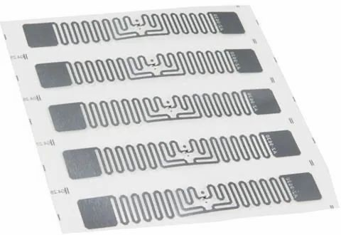

### Figure 2.2 : Passive RFID Tag

Source : https://shorturl.at/ntEIJ

1. RFID Readers Type: Fixed RFID Readers

Specification: These readers are capable of long-range detection, designed to capture data from passive tags at distances of up to 10 meters.

Placement: Installed at strategic locations such as the entrances/exits of the neonatal and maternity wards to ensure comprehensive area coverage and prevent any unauthorized movement.

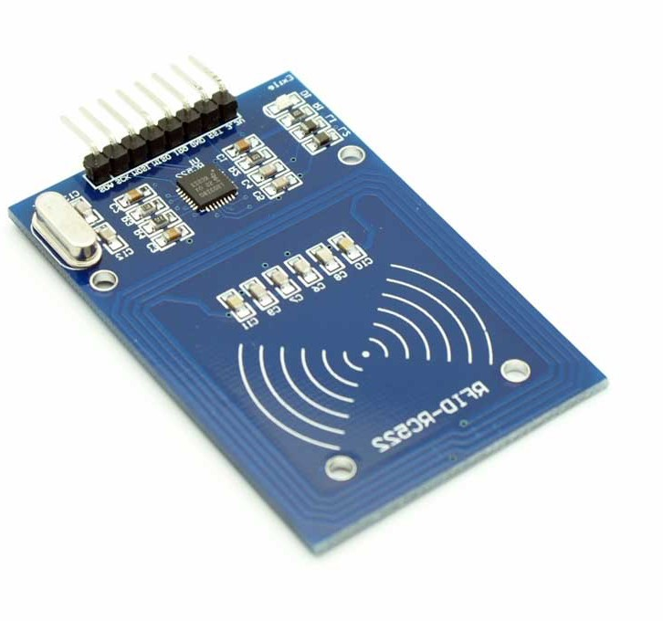

### Figure 2.3 : RFID Reader

Source : https://shorturl.at/hL127

1. Raspberry Pi Pico Type: Microcontroller

Specification: A small, affordable, high-performance microcontroller board built using

the RP2040 microcontroller chip.

Function: Acts as the central processing unit of the prototype, controlling the RFID readers, processing the data received from RFID tags, and managing communications with the hospital’s central information system. The Raspberry Pi Pico is responsible for executing the software logic, including security protocols for data encryption and the interface with the broader hospital network.

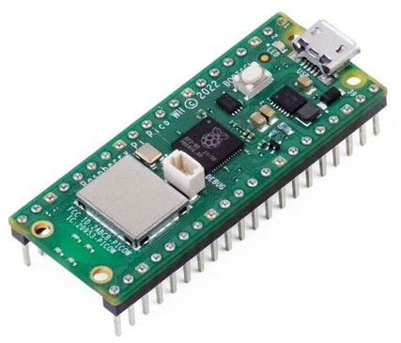

### Figure 2.4 : Raspberry Pi Pico

Source : https://shorturl.at/V2346

### System Integration and Functionality

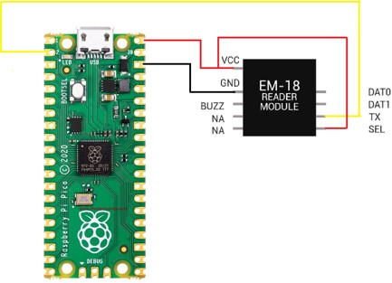The combination of these components results in an effective framework designed specifically for the healthcare sector. RFID tags and readers work together to provide continuous monitoring and tracking for infants. The Raspberry Pi Pico, with its powerful processing capabilities and GPIO (General Purpose Input Output) adaptability, is essential for data logistics, from initial capture by RFID scanners to secure transfer to hospital systems. This arrangement provides an efficient, secure, and scalable system that improves new born safety and streamlines hospital staff procedures.

### Figure 2.5 : Raspberry Pi Pico and RFID Reader Circuit

Source : https://shorturl.at/rITV9

### Conclusion

The literature review carefully examined several RFID systems in new born care, laying a solid foundation for selecting RFID technology combined with the Raspberry Pi Pico for the "Guardian Angels" project. This combination has been proven as the optimum option after rigorous comparison and research, providing improved real- time tracking, security, and integration capabilities critical for improving neonatal safety in hospital setti

# CHAPTER 3

**METHODOLOGY**

### Introduction

The "Guardian Angels" initiative, which aims to improve the safety and efficiency of new born care using Radio Frequency Identification (RFID) technology, requires a precise and flexible approach. This chapter describes the technique used to assure the project's success, focusing on the concepts of the Iterative Software Development Life Cycle (SDLC) model.

The Iterative SDLC model was chosen for its inherent flexibility and responsiveness, which are critical given the dynamic nature of technological integration in healthcare facilities. This approach enables a methodical yet customizable framework, allowing for continuous modification and improvement based on iterative feedback and testing. This strategy not only accommodates the project's shifting requirements, but it also addresses the important demand for precision and reliability in medical applications.

The methodology outlined in this chapter is designed to give a clear roadmap for the development process. It consists of four phases: planning, design, implementation, and evaluation. Each phase is designed to iteratively build on the preceding one, ensuring that each element of the project is rigorously defined, implemented, and reviewed before moving on to the next. This iterative process is critical for reducing risks, improving system functionality, and ensuring that the final output fulfils the demanding requirements of new born medical facilities

In addition to defining each phase of the Iterative model, this chapter will outline the flow of activities using extensive diagrams, establish milestones and critical dates for project management, and provide a Gantt chart for a visual representation of the project timeline. The "Guardian Angels" project aims to develop a robust and effective RFID-based system that is designed to improve new born care outcomes and operational efficiencies.

### Iterative Model Overview

The Iterative Software Development Life Cycle (SDLC) model promotes a progressive approach to software development by breaking it down into repeating cycles or iterations. This methodology is ideal for complex projects like "Guardian Angels," where adaptability and incremental improvements are critical. The Iterative methodology minimizes initial delivery time and provides project flexibility by deploying an initial, basic version of the software early in the development process and improving it over multiple iterations.

Each iteration of this model includes planning, creating, executing, and evaluating phases, allowing for continuous revisions depending on real-time feedback and testing outcomes. This structure enables the early integration of feedback, ensuring that the project remains in constant alignment with customer needs and project goals. Furthermore, it allows for proactive risk management by recognizing and addressing possible concerns throughout the project's lifecycle, rather than only at the beginning. This method not only avoids major disruptions, but also keeps the focus on producing high-quality results.

The benefits of using the iterative methodology in the "Guardian Angels" project include increased adaptability to changing project specifications, which could be due to new research findings or technological breakthroughs. Frequent iterations exhibiting operational product phases boost stakeholder involvement and satisfaction, as observable progress instils confidence and ensures continued support. Furthermore, incorporating continuous testing and assessment during each phase aids in embedding quality from the start, lowering the costs and resources required to resolve concerns later on.

When adopting the Iterative model for "Guardian Angels," the technique entails setting defined objectives for each iteration that specify specific features and capabilities to be developed or refined. This approach assures that each cycle results in a functional version of the system, which is gradually upgraded based on user feedback and technical assessments. This meticulous application of the Iterative model ensures that the project not only meets, but exceeds, the expectations of its users and stakeholders, resulting in a robust and effective RFID-based system adapted for the demanding environment of new born care.

### Phase Description

The "Guardian Angels" project has been designed using the Iterative SDLC model, which allows for a systematic yet flexible approach to the software and hardware integration required to improve new born care. This model is particularly effective since it emphasizes ongoing review and development throughout numerous phases, each of which is described in its own subchapter.

### Planning Phase

The Planning Phase is the first step of each iteration, in which the project's scope and objectives are specified or refined based on the results of the previous cycle. This phase includes extensive requirement collection, which is crucial for matching the project to the specific demands of new born care. Resource allocation and risk assessment are also carried out to guarantee that the project is well-prepared to carry forward successfully. The planning sets the framework for all following actions, ensuring that each iteration starts with a clear and focused direction.

### Design Phase

Following the planning stage, the Design Phase entails creating precise schematics for both the RFID hardware components and the web dashboard. This phase is critical for converting improved requirements into executable designs that will direct construction and programming activities. Prototypes are frequently revisited and improved during this phase, with feedback used to improve usability and usefulness.

The iterative nature of this phase allows for constant modification of the designs, ensuring that they fulfil both technical standards and user expectations.

### Implementation Phase

During the implementation phase, the system is essentially constructed. At this point, the hardware is assembled, and the software for the web dashboard is created. This phase is essential in bringing conceptual designs to reality. It includes extensive internal testing to ensure that the components work together flawlessly and meet the specifications. The implementation phase is iterative, with each cycle adding to the preceding one to improve system functionality and dependability.

### Evaluation Phase

During the Evaluation Phase, all newly installed features and functionalities are thoroughly tested. This step is critical for evaluating the system against the set objectives and ensuring that it performs properly. Feedback from potential users or specialist consultants is critical at this point, offering valuable ideas for the next planning step. This feedback loop is critical for continuous improvement since it allows for changes that increase the system's efficacy and user happiness.

### Flow Chart of Activity

**Figure 3.1 : Flow Chart of Activity**

### Milestone and Date

**Table 3.1: Milestone and Date**

|  |  |  |  |
| --- | --- | --- | --- |
| **Milestone**  **Number** | **Milestone**  **Description** | **Key Activity** | **Due Date** |
| **Milestone**  **1** | End of  Iteration 1 | Developed initial RFID prototype  and basic web dashboard | 7/2/2024 |
| **Milestone 2** | End of Iteration 2 | Improved RFID functionality, integrated first round of user  feedback into the dashboard | 9/3/2024 |
| **Milestone 3** | End of Iteration 3 | Finalized RFID system and web dashboard, prepared for deployment and conducted final  system testing | 11/5/2024 |

### Gantt Chart

In Appendix A, a detailed Gantt chart is presented to illustrate the project schedule for the "Guardian Angels." This chart provides a clear timeline of the project's milestones and the key activities for each developmental iteration, from the initial prototyping to the final system deployment and testing, aligning with the iterative SDLC approach outlined in this subchapter

# CHAPTER 4

# SYSTEM ANALYSIS AND DESIGN

### Introduction

This chapter describes the system analysis and design procedures used in the creation of an RFID-based newborn care system. The goal is to provide a thorough understanding of how the system requirements were obtained and how the system was created to meet them. The chapter is organised into numerous sections, beginning with the methods for eliciting requirements and progressing to the detailed system design, which includes several diagrams and data descriptions. The final section discusses the design of the user interface, which ensures that the system is both functional and usable. This organised method ensures that all components of the system are thoroughly analysed and efficiently created to satisfy the users' requirements.

### System Analysis

System analysis is an important stage in the development of the "Guardian Angels" RFID-based newborn care system. This phase guarantees that the system's functionality fulfils its users' requirements and expectations. We used two main strategies for eliciting requirements: document analysis and questionnaires. These methods were chosen to provide a thorough overview of current processes, identify potential gaps, and solicit feedback from healthcare experts who will use the system. The findings of this research lay the groundwork for the system's design and implementation, ensuring that it is both effective and user-friendly.

### Document Analysis

Document analysis involves conducting a systematic assessment of printed and electronic materials. This strategy was chosen for this research because there are numerous extensive technical documents, academic papers, and review articles that provide detailed insights into the deployment and application of RFID technology in healthcare. Document analysis is especially beneficial for understanding existing systems, establishing best practices, and detecting possible issues and solutions. According to Bowen (2009), document analysis is an economical and successful method of data collection since documents are stable, inconspicuous, and can be checked repeatedly.

Several major discoveries emerged from the examination of relevant literature, which will help shape the "Guardian Angels" system. For example, the document "Applying RFID Systems to Improve the Correctness of Newborn Identity Reconfirmation" investigates the use of RFID technology to improve the correctness of newborn identity validation. This document describes the implementation procedure, including the use of RFID tags for infants and their mothers, as well as the integration of hospital network technology to ensure accurate identification. The benefits of RFID in decreasing manual errors and enhancing patient safety are highlighted, making this resource important for learning about the use of RFID in newborn identification and monitoring (Applying RFID Systems to Improve the Correctness of Newborn Identity Reconfirmation).

Similarly, the review paper "RFID Technology in Healthcare: Benefits, Challenges, Opportunities" gives a thorough overview of RFID technology in healthcare, including its history, benefits, and challenges. The study explores several RFID applications, including inventory management and patient tracking, and emphasizes the technology's potential to transform healthcare by automating operations and improving data accuracy. This assessment provides critical context for the project by helping to grasp the broader implications of RFID technology in hospital settings (Kumar, Swanson, & Tran, 2020).

The bachelor's thesis "Hospital Inpatient Tracking System Using RFID Technology" describes the creation of an RFID-powered system for monitoring

inpatients in a hospital setting. It covers the system's architecture, implementation, and benefits, such as reduced overcrowding and improved patient monitoring. The thesis contains detailed descriptions of the system's components, data flow diagrams, and user interfaces, as well as practical insights into how to create an RFID tracking system in a hospital setting (Chia).

"A Remote Baby Surveillance System with RFID and GPS Tracking," a research article, describes a system that employs RFID and GPS technologies to monitor and track infants' locations. The paper describes the hardware and software components, system architecture, and benefits of real-time monitoring, with a focus on assuring infant safety utilizing advanced tracking technologies. This document is useful for learning how RFID and GPS can be combined to improve neonatal tracking and monitoring (Wang, Chao, & Liu, 2011).

The study "Improved Wireless Sensors to Monitor Babies in Neonatal Intensive Care" explores the use of wireless sensors to monitor newborns in neonatal intensive care units (NICUs). It emphasizes the advantages of wireless monitoring over traditional techniques, such as better data collection and patient care, as well as the implementation procedure and benefits for healthcare practitioners and patients. This publication discusses enhanced monitoring technologies that can supplement RFID systems in neonatal care (Improved Wireless Sensors to Monitor Babies in Neonatal Intensive Care).

The review of "RFID-Enabled Healthcare Applications, Issues and Benefits: An Archival Analysis (1997-2011)" looks at RFID applications in healthcare during a 14-year period. The paper explores the benefits and obstacles of deploying RFID in healthcare, covering use cases such as patient tracking, inventory management, and workflow enhancement. This document presents a historical overview of RFID use in healthcare, noting both triumphs and ongoing concerns (RFID-Enabled Healthcare Applications, Issues and Benefits: An Archival Analysis (1997-2011)).

Finally, the review paper "RFID Technology in Healthcare: Benefits, Challenges, and Opportunities" investigates the advantages, disadvantages, and opportunities provided by RFID technology in healthcare. The study focuses on how

RFID can improve patient safety, decrease errors, and increase operational efficiency. It also emphasizes the significance of appropriate training, data security, and infrastructure in facilitating RFID implementation (RFID Technology in Healthcare: Benefits, Challenges, and Opportunities).

These materials provide a thorough overview of the different elements and applications of RFID technology in healthcare. They offer vital insights into practical implementation, benefits, and obstacles that will inform the design and development of the "Guardian Angels" RFID-based child care system.

### Questionnaires

To enhance the requirement elicitation process, questionnaires were used to collect detailed information from the Guardian Angels system's end-users. These questions were developed after the document analysis phase to guarantee that all relevant components of the system were addressed. The goal of using the document analysis findings to support the questionnaire design was to address any gaps and properly validate the requirements.

The goal of using surveys was to gather thorough feedback from medical personnel who use the system on a daily basis. Their responses offered useful information about the system's existing capabilities, usability difficulties, and prospective areas for improvement. The questionnaires were designed to be concise yet comprehensive, focusing on several key areas: general information about respondents and their roles, the registration process for mothers and infants, infant tracking and monitoring, medication administration, alerts and notifications, overall system usability, and suggestions for improvement.

Several key observations were gleaned from the medical personnel's comments. The majority of respondents have been in their current positions for more than three years and engage with the newborn tracking system several times per day. Respondents stated that the existing registration process is time-consuming and error-prone, emphasizing the need for a more efficient and user-friendly registration interface. Medical workers regularly need to track the location of infants, particularly

in critical care units. The existing system occasionally fails to give real-time updates, resulting in delays and significant safety concerns.

Furthermore, the drug administration feature was discovered to lack an intuitive design, making it difficult to precisely record and maintain prescription schedules. Respondents stressed the need of automatic reminders and improved record-keeping. While alerts and notifications are generally useful, there have been instances of false alarms and missed messages, emphasizing the importance of enhancing alert accuracy and reliability.

Overall, the system is thought to be positive, but it has to be improved in order to be more useful and effective. Respondents suggested a more intuitive user interface, improved real-time tracking capabilities, and more dependable alarm methods. By incorporating these observations into the system design, the Guardian Angels project hopes to create a more efficient, user-friendly, and dependable RFID- based child care system that satisfies the needs of its customers.

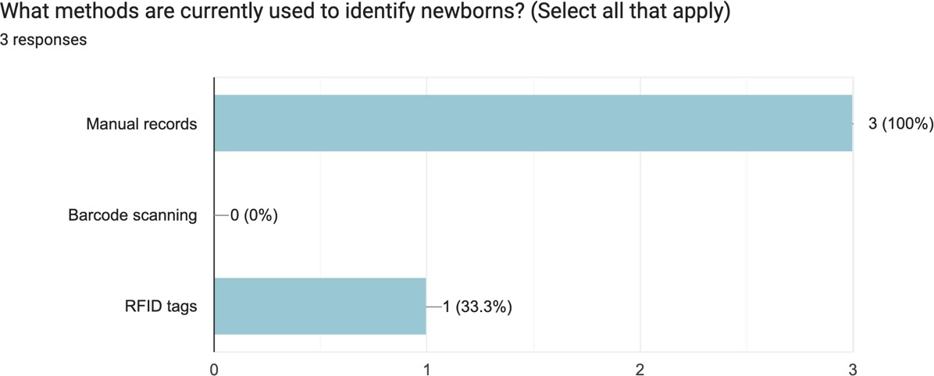

### Figure 4.1 : Methods currently used to identify newborn

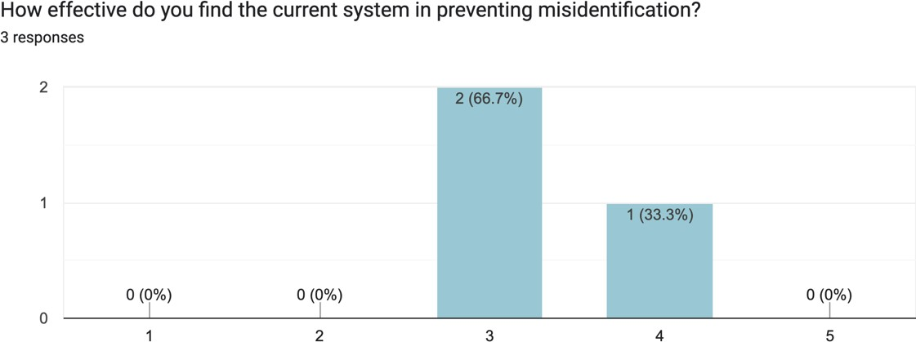

**Figure 4.2 : Effectiveness of current system in preventing misidentification**

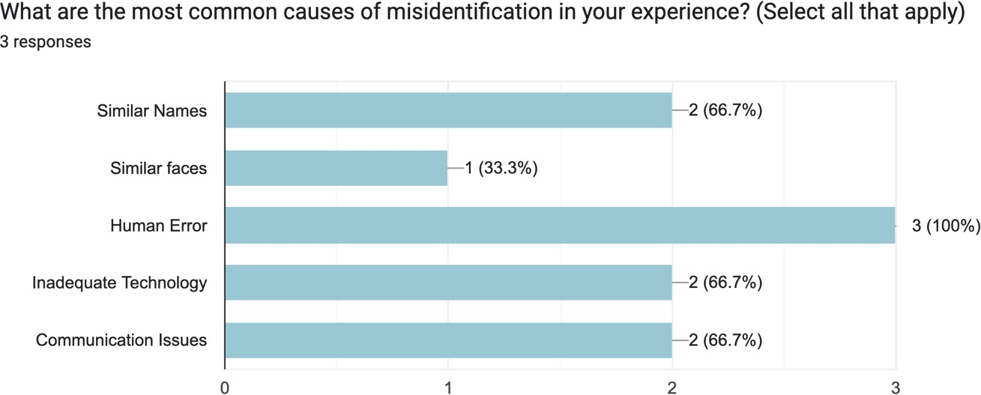

### Figure 4.3 : Most common case of misidentification

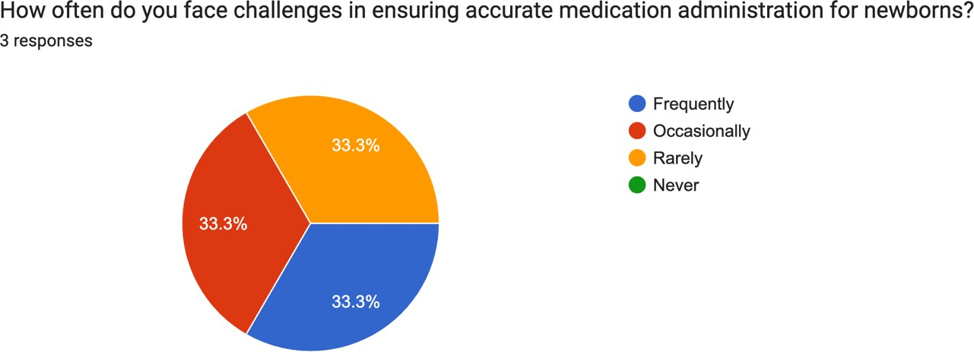

**Figure 4.4 : Challenges ensuring accurate medication administration in newborn**

### System Design.

The system design phase transforms the requirements acquired during the analysis phase into a structured model that defines the system's components and interconnections. This includes developing use case diagram, context diagrams, data flow diagrams (DFDs), and entity-relationship diagrams (ERDs) to visually represent the system's architecture and data flow.

### Use Case Diagram

### Use case Description

### Table 4.1 : Use Case Description – Register Mother

|  |  |
| --- | --- |
| Use Case Name: | Register mother |
| Use Case ID: | UC001 |
| Actor: | Medical Personnel |
| Description: | This use case allows medical personnel to register a mother's  information into the system. |
| Trigger: | Medical personnel want to create a new record for a mother |
| Preconditions: | Medical personnel must be authenticated. |
| Main path: | * Medical personnel navigates to the "Register Mother" page. * Medical personnel fills in the required registration details. * Medical personnel submits the registration form. |

|  |  |
| --- | --- |
|  | * The system validates the information. * The system creates a new record and stores the mother's information. * The system confirms the registration. |
| Alternate path: | 1. If the registration information is invalid, the system displays an error message. 2. Medical personnel corrects the information and resubmits the form. |
| Postconditions: | 1. The mother's record is created and stored in the system. |

**Table 4.2 : Use Case Description – Register Infant**

|  |  |
| --- | --- |
| Use Case Name: | Register newborn |
| Use Case ID: | UC002 |
| Actor: | Medical Personnel |
| Description: | This use case allows medical personnel to register a  newborn's information into the system. |
| Trigger: | Medical personnel want to create a new record for a  newborn |
| Preconditions: | Medical personnel must be authenticated. and the mother  must be registered. |
| Main path: | * Medical personnel navigates to the "Register Infant" page. * Medical personnel selects the mother and fills in the required registration details for the infant. * Medical personnel submits the registration form. * The system validates the information. * The system creates a new record and stores the infant's information. * The system confirms the registration. |

|  |  |
| --- | --- |
| Alternate path: | * 1.If the registration information is invalid, the system displays an error message. * 2.Medical personnel corrects the information and resubmits the form. |
| Postconditions: | The newborn's record is created and stored in the  system. |

### Table 4.3 : Use Case Description – Assign RFID Tag to Infant

|  |  |
| --- | --- |
| Use Case Name: | Assign RFID Tag to Infant |
| Use Case ID: | UC003 |
| Actor: | Medical Personnel |
| Description: | This use case allows medical personnel to assign an RFID  tag to an infant. |
| Trigger: | Medical personnel wants to assign an RFID tag to an infant. |
| Preconditions: | Medical personnel must be authenticated, and the infant  must be registered. |
| Main path: | * Medical personnel navigates to the "Assign RFID Tag" page. * Medical personnel selects the infant and the RFID tag. * Medical personnel assigns the RFID tag to the infant. * The system validates the information. * The system updates the infant's record with the RFID tag information.   The system confirms the assignment. |
| Alternate path: | * If the assignment information is invalid, the system displays an error message. * Medical personnel corrects the information and resubmits the form. |
| Postconditions: | The RFID tag is assigned to the infant and stored in the  system. |

**Table 4.4 : Use Case Description – Enter Medication Details**

|  |  |
| --- | --- |
| Use Case Name: | Enter Medication Details |
| Use Case ID: | UC004 |
| Actor: | Medical Personnel |
| Description: | This use case allows medical personnel to enter and update  medication details for an infant. |
| Trigger: | Medical personnel need to input or update medication  details. |
| Preconditions: | Medical personnel must be authenticated. |
| Main path: | * Medical personnel navigates to the "Assign RFID Tag" page. * Medical personnel selects the infant and the RFID tag. * Medical personnel assigns the RFID tag to the infant. * The system validates the information. * The system updates the infant's record with the RFID tag information.   The system confirms the assignment. |
| Alternate path: | * If the assignment information is invalid, the system displays an error message. * Medical personnel corrects the information and   resubmits the form. |
| Postconditions: | The RFID tag is assigned to the infant and stored in the  system. |

### Table 4.5 : Use Case Description –Generate Alerts

|  |  |
| --- | --- |
| Use Case Name: | Generate Alerts |
| Use Case ID: | UC005 |
| Actor: | Medical Personnel |
| Description: | This use case allows the system to generate alerts when an  infant exits a designated area. |
| Trigger: | The system detects an infant passing through a reader. |

|  |  |
| --- | --- |
| Preconditions: | The infant must have an RFID tag assigned. |
| Main path: | * The RFID reader detects the infant passing through. * The system logs the event. * The system generates an alert. * Medical personnel receives the alert. |
| Alternate path: | If the reader fails to detect the tag, the system logs an  error. |
| Postconditions: | An alert is generated and addressed by the medical  personnel. |

**Table 4.6 : Use Case Description – Monitor Infant Location**

|  |  |
| --- | --- |
| Use Case Name: | Monitor Infant Location |
| Use Case ID: | UC006 |
| Actor: | Medical Personnel |
| Description: | This use case allows medical personnel to monitor the  location of infants. |
| Trigger: | Medical personnel needs to monitor infants' locations. |
| Preconditions: | Medical personnel must be authenticated. |
| Main path: | * Medical personnel navigates to the "Monitor newborn Location" page. * The system displays the location logs of all newborn. * Medical personnel monitors the locations as needed. |
| Alternate path: | If the system fails to retrieve location data, it displays an  error message. |
| Postconditions: | newborns' locations are monitored in real-time. |

### Table 4.7 : Use Case Description – Track Log

|  |  |
| --- | --- |
| Use Case Name: | Track Log |
| Use Case ID: | UC007 |

|  |  |
| --- | --- |
| Actor: | Medical Personnel |
| Description: | This use case allows the system to track and log the  movements of newborns. |
| Trigger: | The system detects movements through RFID readers. |
| Preconditions: | newborn must have RFID tags assigned. |
| Main path: | * RFID readers detect infant movements. * The system logs the movement data. * The system updates the location history. |
| Alternate path: | If the reader fails to detect the tag, the system logs an  error. |
| Postconditions: | Movement data is stored in the system. |

**Table 4.8 : Use Case Description – View Dashboard**

|  |  |
| --- | --- |
| Use Case Name: | View Dashboard |
| Use Case ID: | UC008 |
| Actor: | Medical Personnel, System Administrator |
| Description: | his use case allows users to view the system dashboard,  which includes alerts, notifications, and other relevant information. |
| Trigger: | Users need to view system status and alerts. |
| Preconditions: | Users must be authenticated. |
| Main path: | * User navigates to the "View Dashboard" page. * The system displays the dashboard with real-time data. * User reviews the information. |
| Alternate path: | If the system fails to load the dashboard, it displays an  error message. |
| Postconditions: | Users view and interact with the dashboard. |

### Table 4.9 : Use Case Description – Hardware Connection

|  |  |
| --- | --- |
| Use Case Name: | Hardware Connection |
| Use Case ID: | UC009 |
| Actor: | System Administrator |

|  |  |
| --- | --- |
| Description: | This use case allows the system administrator to check the  status of hardware connections. |
| Trigger: | System administrator needs to verify hardware  connectivity. |
| Preconditions: | System administrator must be authenticated. |
| Main path: | * System administrator navigates to the "Hardware Connection" page. * The system displays the status of all hardware components. * System administrator reviews the status. |
| Alternate path: | If the system fails to retrieve hardware status, it displays  an error message |
| Postconditions: | Hardware status is verified and monitored. |

**Table 4.10 : Use Case Description – Print Report**

|  |  |
| --- | --- |
| Use Case Name: | Print Report |
| Use Case ID: | UC010 |
| Actor: | System Administrator |
| Description: | This use case allows the system administrator to generate  and print reports. |
| Trigger: | System administrator needs to generate a report. |
| Preconditions: | System administrator must be authenticated. |
| Main path: | * System administrator navigates to the "Print Report" page. * System administrator selects report parameters. * The system generates the report. * System administrator prints the report. |
| Alternate path: | * If the system fails to generate the report, it displays an error message. * System administrator corrects the parameters and retries. |

|  |  |
| --- | --- |
| Postconditions: | The report is generated and printed. |

### Table 4.11 : Use Case Description – Push Medication Notification

|  |  |
| --- | --- |
| Use Case Name: | Push Medication Notification |
| Use Case ID: | UC011 |
| Actor: | Medical Personnel |
| Description: | This use case allows the system to push a notification to  medical personnel when a baby needs to be administered medications based on the medication schedule. |
| Trigger: | The system checks the medication schedule and  determines it is time for a baby to be administered medication. |
| Preconditions: | * Medication details must have been entered and stored in the system. * Medical personnel must be authenticated. |
| Main path: | * The system continuously monitors the medication schedule for all infants. * When the system detects that it is time for a baby to receive medication, it generates a notification. * The system pushes the notification to the medical personnel's dashboard. * Medical personnel receive the notification on their dashboard. * Medical personnel administer the medication to the baby. * Medical personnel confirm the administration of the medication in the system.   The system logs the administration time and  updates the medication record. |
| Alternate path: | * If the system fails to generate the notification, it logs an error. * Medical personnel manually check the medication   schedule and administer the medication. |

|  |  |
| --- | --- |
|  | * Medical personnel confirm the administration of the medication in the system. * The system logs the administration time and updates the medication record. |
| Postconditions: | * A notification is pushed to the medical personnel. * The baby receives the required medication as scheduled. * The medication administration is logged and   updated in the system. |

* + 1. 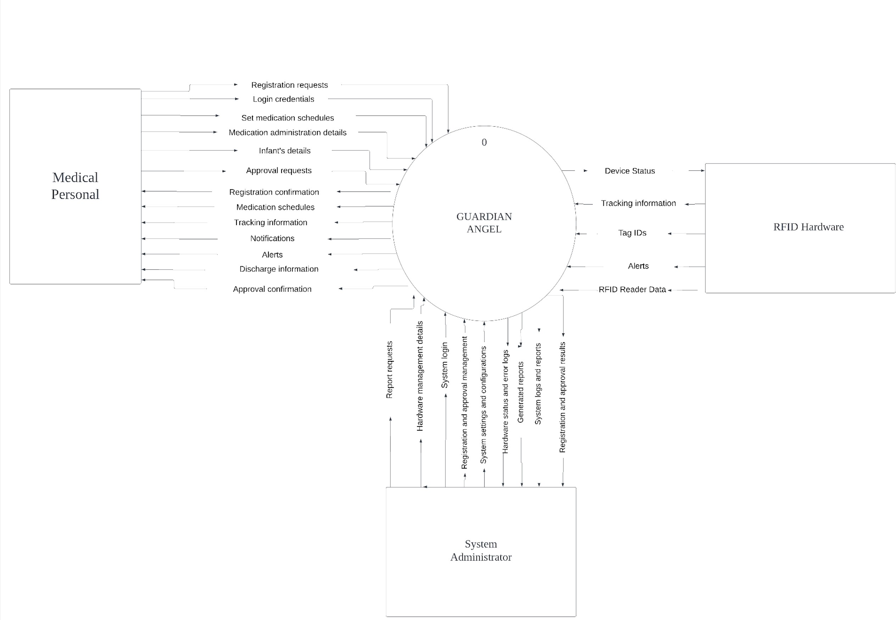**Context Diagram**

### Data Flow Diagram Level 0

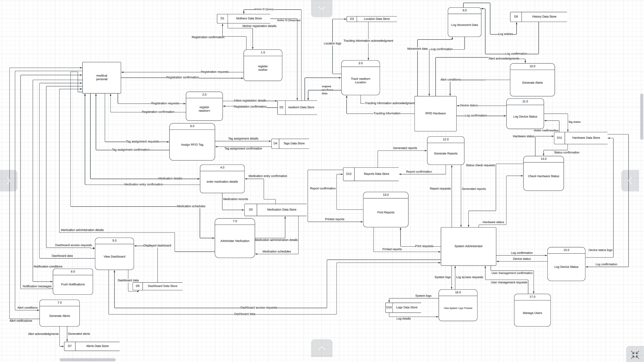

### Data Flow Diagram Level 1

### Mother Registration

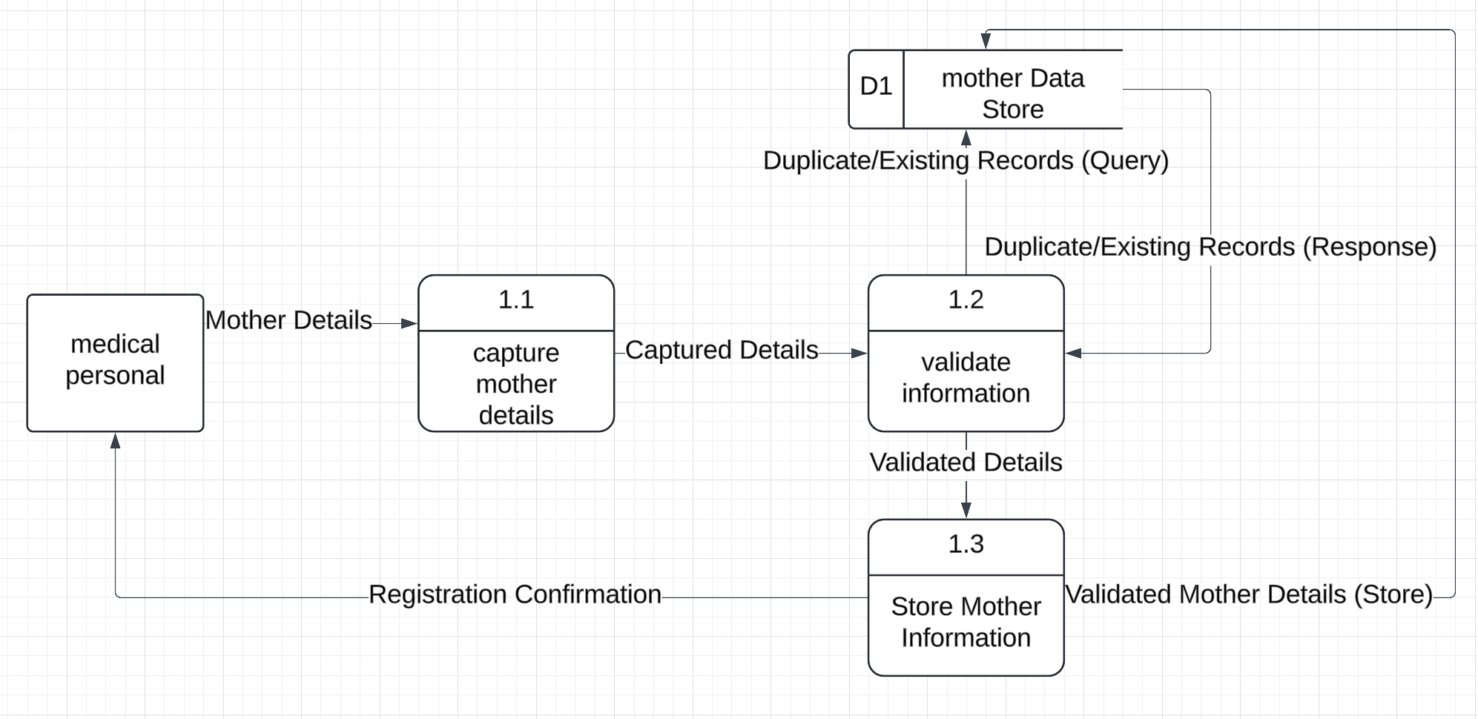

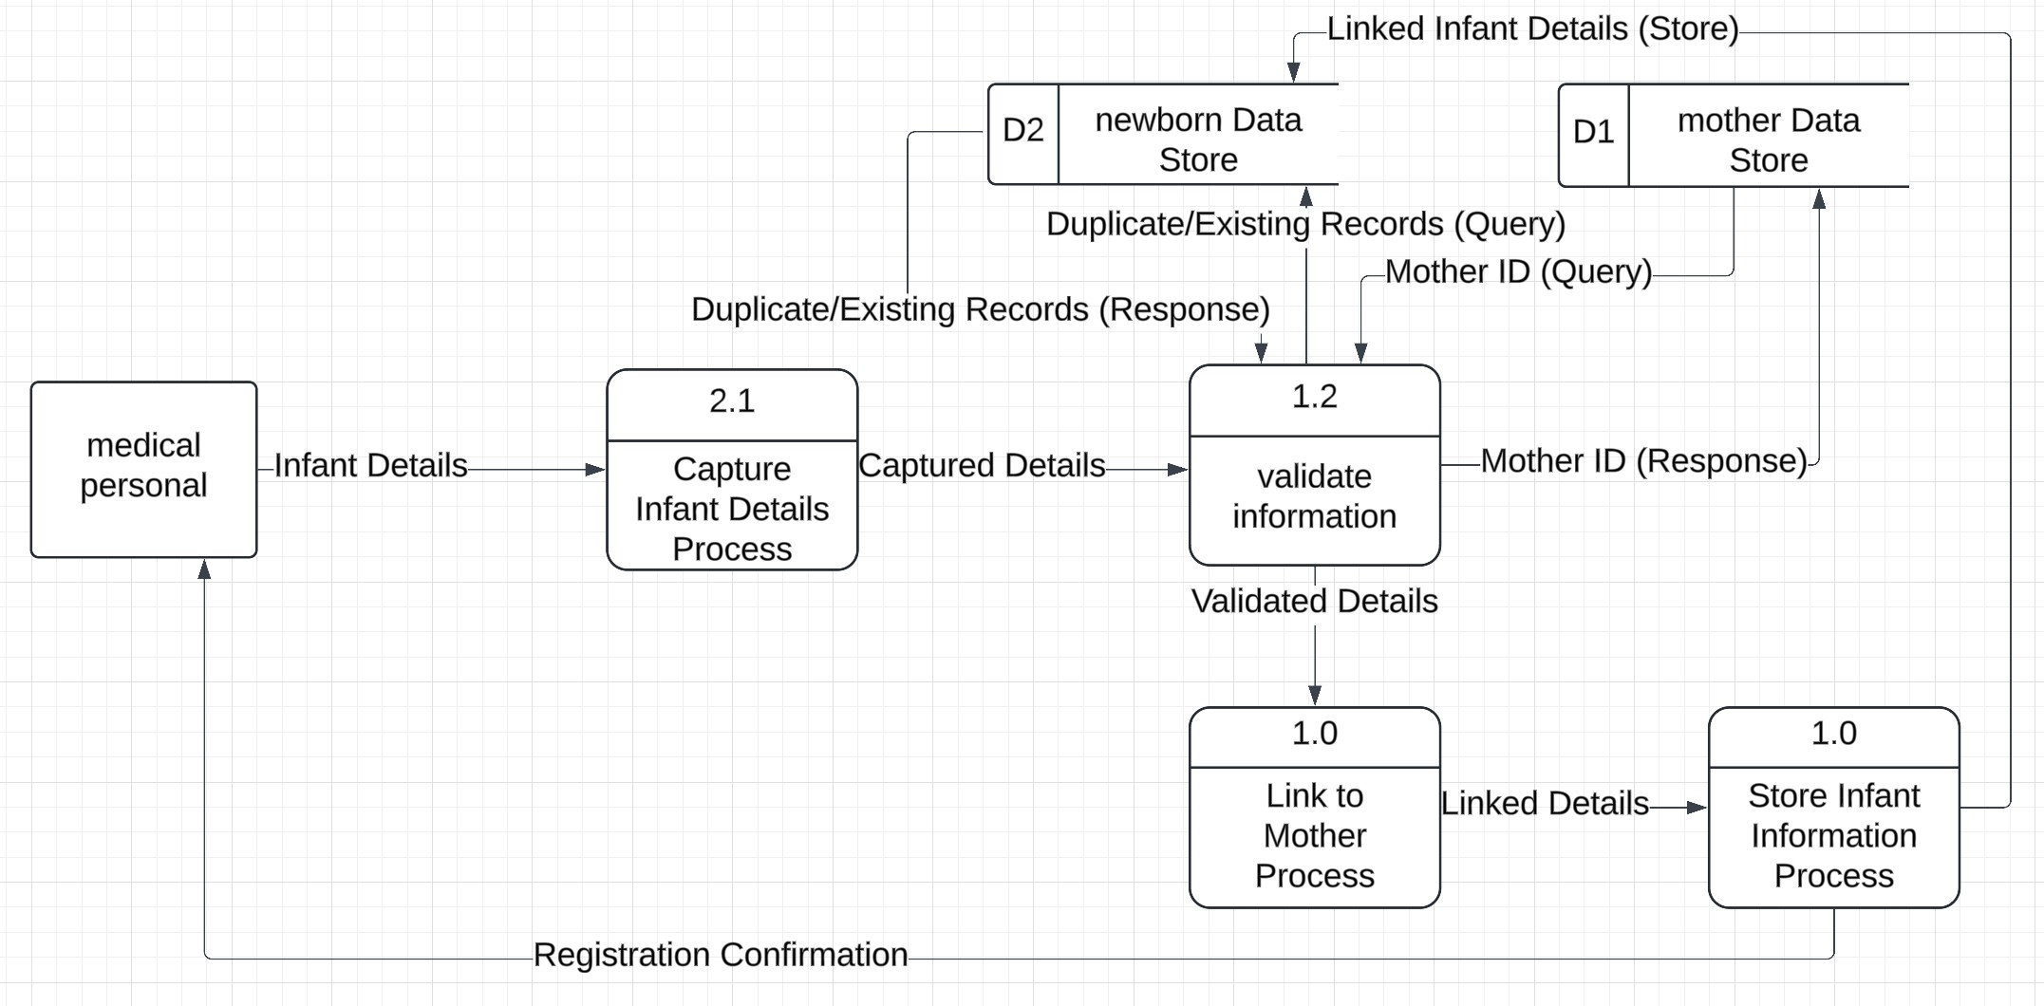**Newborn Registration**

### Tag Assignment

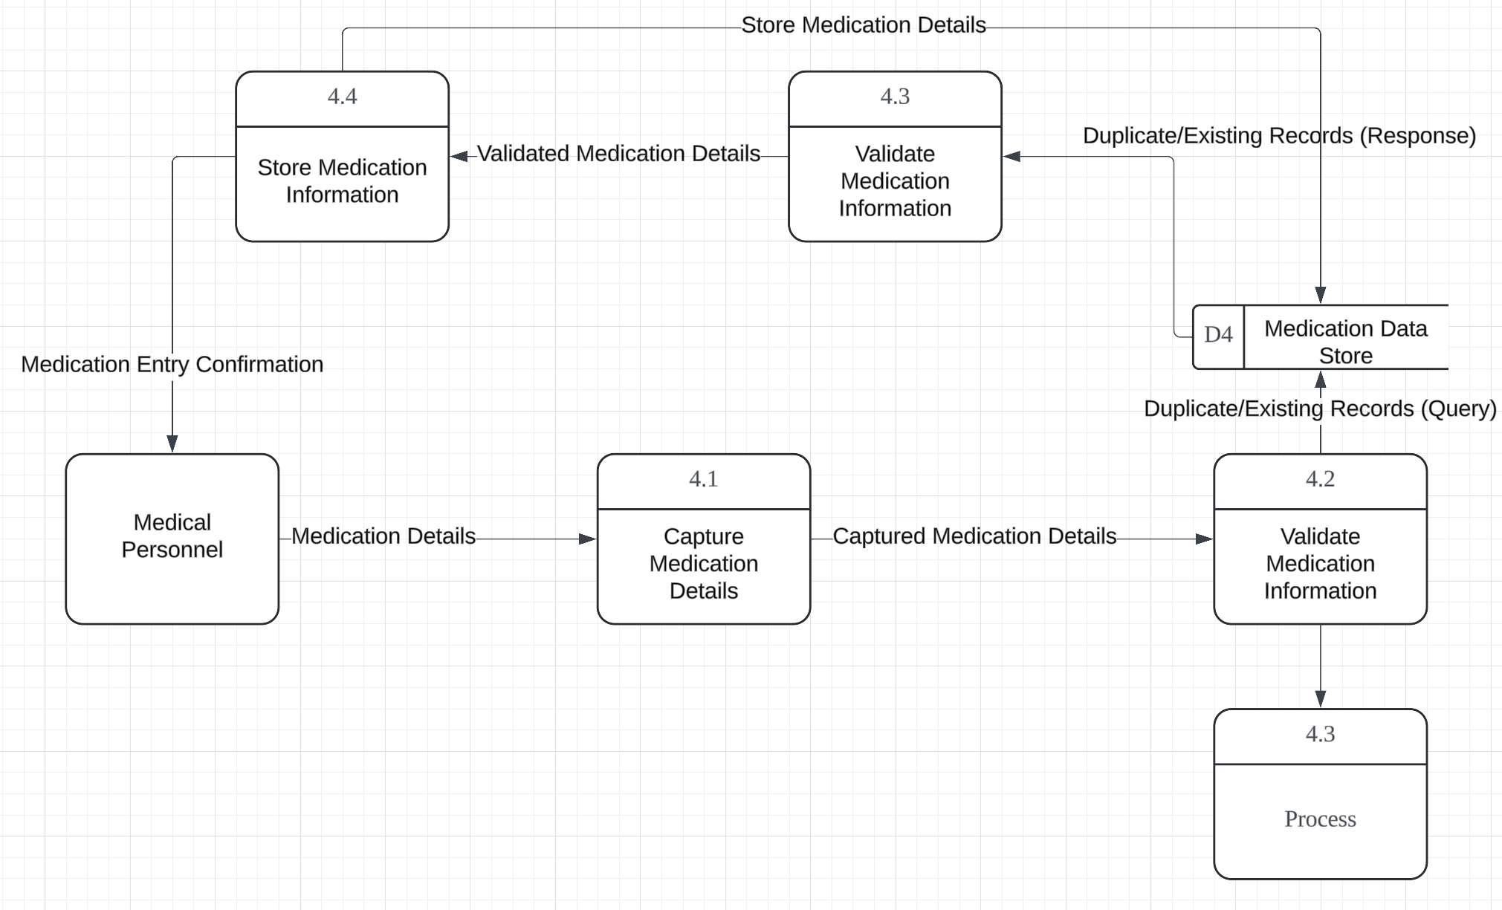**Medication Admission**

### Medication Administration

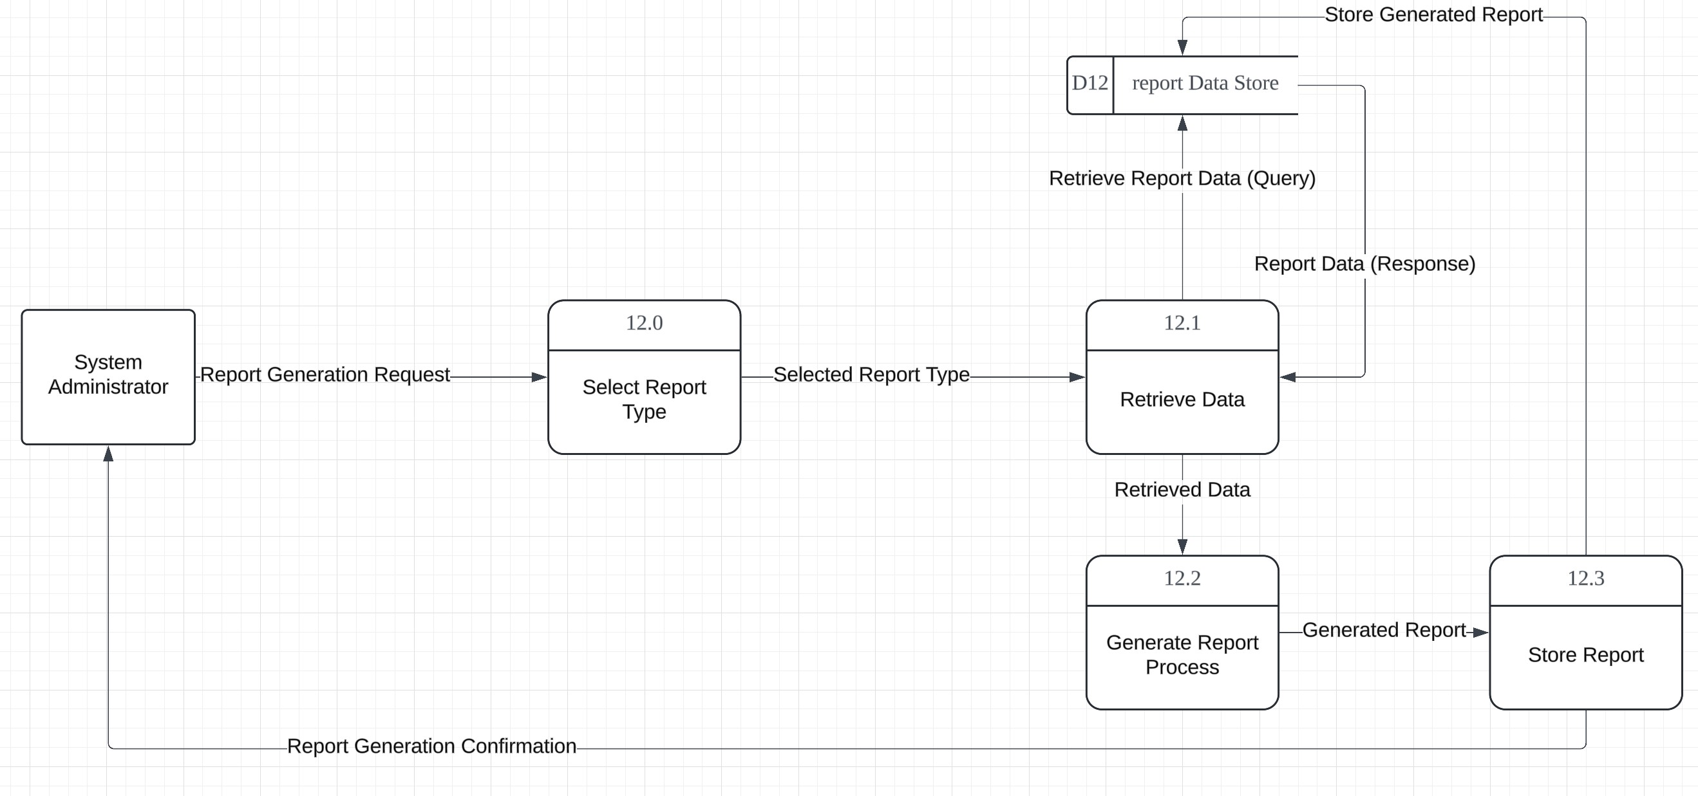**Report Generating**

### Monitor Hardware

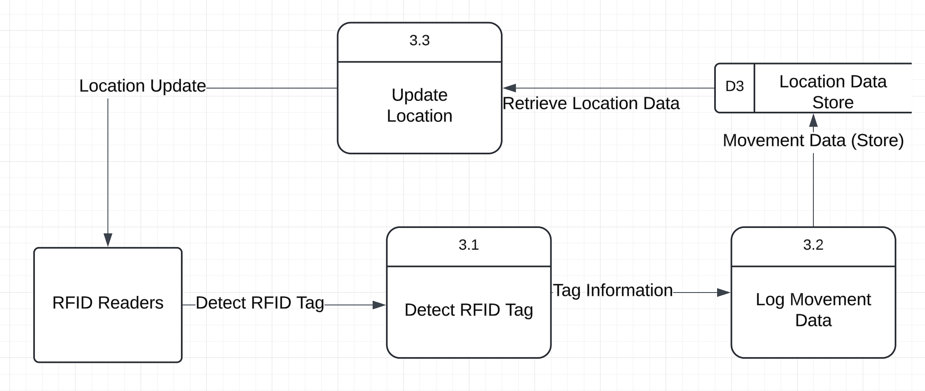**Location Tracking**

### 4.3.4 Entity-Relationship Diagram

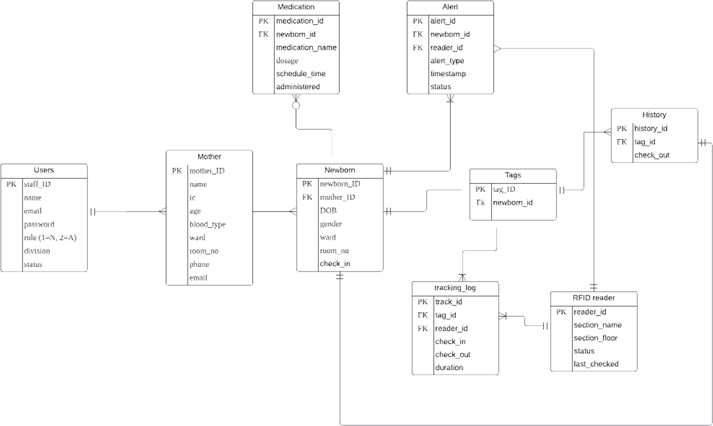

### Data Dictionary

### Table 4.12: Data Dictionary for Users Table

|  |  |  |
| --- | --- | --- |
| **Attribute** | **Datatype** | **Description** |
| staff_ID | int(11) | Unique identifier for each staff member |
| name | varchar(255) | Name of the staff member |
| email | varchar(255) | Email address of the staff member |
| password | varchar(255) | Password for the staff member's  account |
| role | int(1) | Role of the staff member (1=Admin,  2=Medical Personnel) |
| division | varchar(255) | Division or department the staff  member belongs to |
| status | varchar(20) | Status indicating whether the staff  member is active or inactive |

**Table 4.13: Data Dictionary for Mother Table**

|  |  |  |
| --- | --- | --- |
| **Attribute** | **Datatype** | **Description** |
| mother_ID | int(11) | Unique identifier for each  mother |
| name | varchar(255) | Name of the mother |
| ic | varchar(20) | Identification card  number of the mother |
| age | int(3) | Age of the mother |
| blood_type | varchar(3) | Blood type of the mother |
| ward | varchar(255) | Ward where the mother is  staying |
| room_no | varchar(10) | Room number where the  mother is staying |
| phone | varchar(20) | Phone number of the  mother |
| email | varchar(255) | Email address of the  mother |

### Table 4.14: Data Dictionary for Newborn Table

|  |  |  |
| --- | --- | --- |
| **Attribute** | **Datatype** | **Description** |
| newborn_ID | int(11) | Unique identifier for each  newborn |
| mother_ID | int(11) | Foreign key linking to the  mother |
| DOB | date | Date of birth of the  newborn |
| gender | varchar(10) | Gender of the newborn |
| ward | varchar(255) | Ward where the newborn  is staying |
| room_no | varchar(10) | Room number where the  newborn is staying |
| check_in | timestamp | Check-in timestamp for  the newborn |

**Table 4.15: Data Dictionary for Tags Table**

|  |  |  |
| --- | --- | --- |
| **Attribute** | **Datatype** | **Description** |
| tag_ID | int(11) | Unique identifier for each  RFID tag |
| newborn_ID | int(11) | Foreign key linking to the  newborn |
| rfid_tag_id | varchar(255) | RFID tag identifier |

### Table 4.16: Data Dictionary for RFID Reader Table

|  |  |  |
| --- | --- | --- |
| **Attribute** | **Datatype** | **Description** |
| reader_id | int(11) | Unique identifier for each  RFID reader |
| section_name | varchar(255) | Name of the section where the reader is  located |
| section_floor | varchar(255) | Floor where the reader is  located |
| status | varchar(20) | Status of the RFID reader  (online/offline) |
| last_checked | timestamp | Last checked timestamp  of the RFID reader |

**Table 4.17: Data Dictionary for Tracking Log Table**

|  |  |  |
| --- | --- | --- |
| **Attribute** | **Datatype** | **Description** |
| track_id | int(11) | Unique identifier for each  tracking log entry |
| tag_id | int(11) | Foreign key linking to the  RFID tag |
| reader_id | int(11) | Foreign key linking to the  RFID reader |
| newborn_id | int(11) | Foreign key linking to the  newborn |

|  |  |  |
| --- | --- | --- |
| check_in | timestamp | Check-in timestamp for  the log entry |
| check_out | timestamp | Check-out timestamp for  the log entry |
| duration | int(11) | Duration of stay in the  area |

### Table 4.18: Data Dictionary for History Table

|  |  |  |
| --- | --- | --- |
| **Attribute** | **Datatype** | **Description** |
| history_id | int(11) | Unique identifier for each  history entry |
| tag_id | int(11) | Foreign key linking to the  RFID tag |
| check_out | timestamp | Check-out timestamp for  the history entry |

**Table 4.19: Data Dictionary for Medication Table**

|  |  |  |
| --- | --- | --- |
| **Attribute** | **Datatype** | **Description** |
| medication_id | int(11) | Unique identifier for each  medication entry |
| newborn_id | int(11) | Foreign key linking to the  newborn |
| medication_name | varchar(255) | Name of the medication |
| dosage | varchar(255) | Dosage of the medication |
| schedule_time | timestamp | Scheduled time for the  medication administration |
| administered | timestamp | Actual time the medication was  administered |

### Table 4.20: Data Dictionary for Alert Table

|  |  |  |
| --- | --- | --- |
| **Attribute** | **Datatype** | **Description** |
| alert_id | int(11) | Unique identifier for each  alert |
| newborn_id | int(11) | Foreign key linking to the  newborn |
| reader_id | int(11) | Foreign key linking to the  RFID reader |
| tag_id | int(11) | Foreign key linking to the  RFID tag |
| alert_type | varchar(255) | Type of alert (e.g.,  movement, medication) |
| timestamp | timestamp | Timestamp when the  alert was generated |
| status | varchar(20) | Status of the alert (e.g.,  acknowledged, resolved) |

### System Architecture

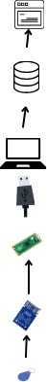

### Figure 4.5 : System architecture of Guardian Angel

The provided system architecture for the "Guardian Angels" RFID-based newborn care system depicts a simplified and efficient setup intended for usage on a Local Area Network (LAN). The architecture starts with an RFID tag, which is attached to each infant and has a unique identification code. When an infant exits a room, an RFID Reader detects and scans the tag's information. This data is then transferred to a Raspberry Pi Pico, a compact and powerful computing device that processes data from the RFID Reader.

The processed data is delivered over a USB interface, which connects the Raspberry Pi to the server. This interface allows for easy data flow between the Raspberry Pi and the server. The server is the central processing unit that manages and processes data. It receives and processes data from the Raspberry Pi, handles the system's business logic, and communicates with the database.

The database is a vital component that stores all data, including tracking logs, newborn information, RFID tag data, medication records, alerts, and other pertinent information. Finally, a web interface makes the user-facing program available to medical personnel and system administrators. This interface enables users to interact with the system, examine real-time statistics, manage registrations, enter prescription information, and receive system warnings and notifications.

In essence, the architecture enables efficient and secure tracking, monitoring, and data management within a hospital's LAN environment, hence enhancing newborn care and safety.

### User Interface and Design

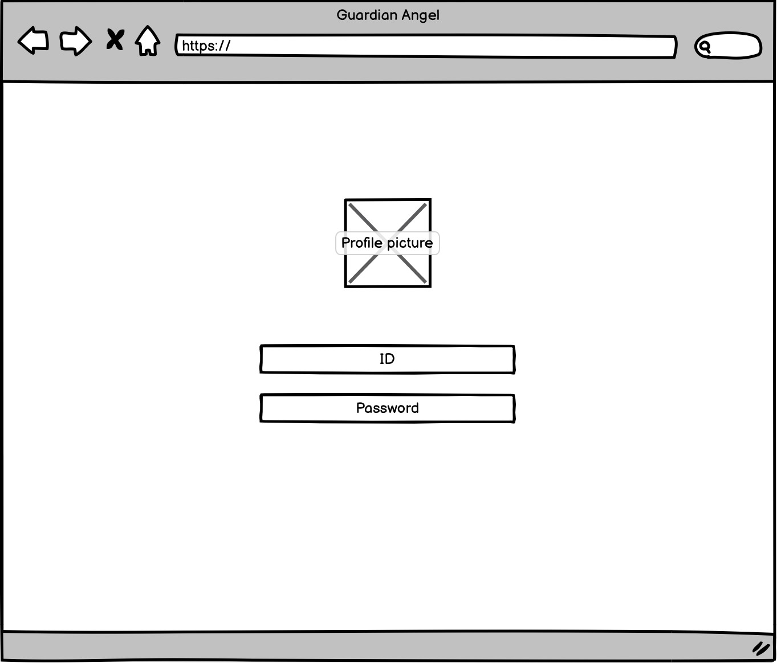

**Figure 4.6: Login Page**

The login page is the initial screen that users encounter when accessing the "Guardian Angels" system. It provides fields for entering a username and password, ensuring secure access to the system. The design includes a simple and intuitive

interface to minimize errors during login attempts. Users must be authenticated to proceed to other functionalities of the system.

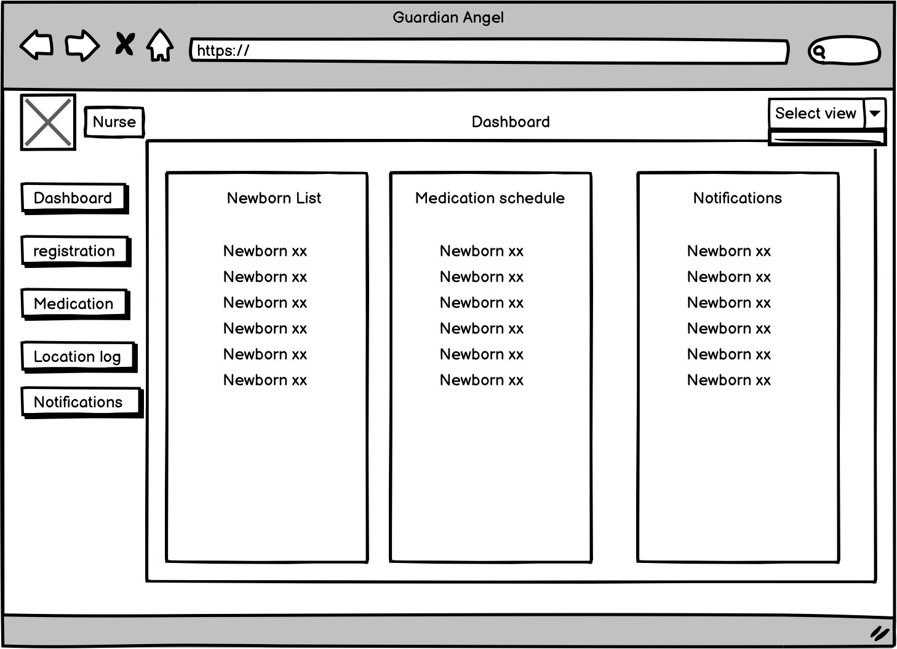

### Figure 4.13: Dashboard (medical personal) Page

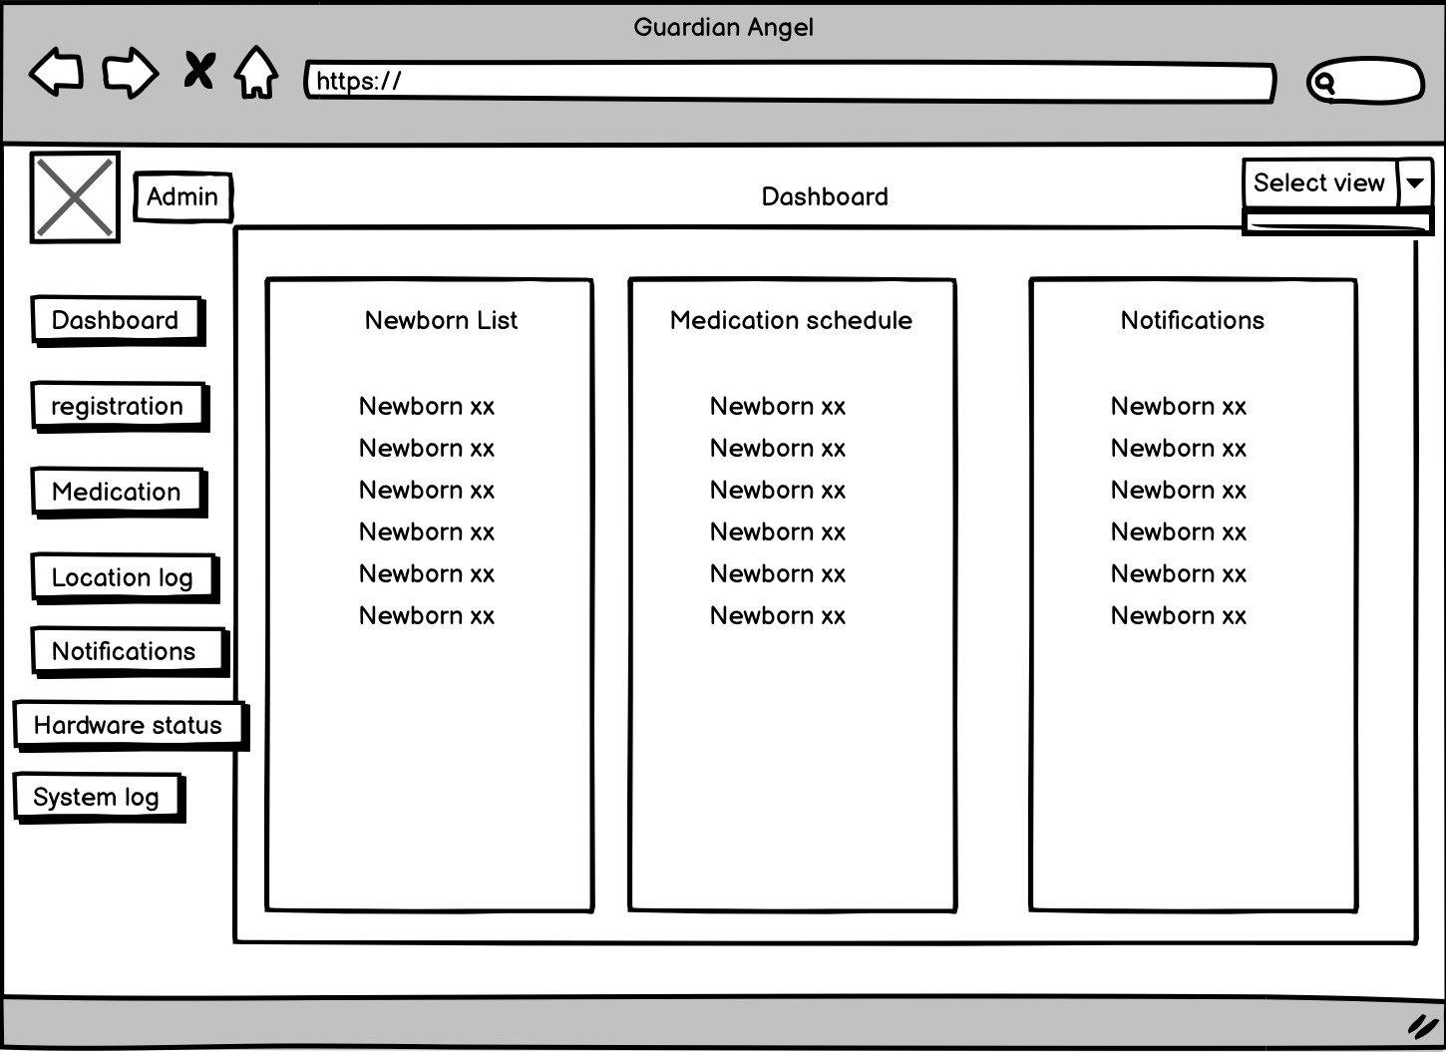

**Figure 4.13: Dashboard(admin) Page**

The dashboard serves as the main interface for users, providing an overview of system activities and key information. It displays real-time data on infant locations, alerts, and system status. The dashboard is designed to be user-friendly, allowing quick access to essential features such as monitoring newborn movements and viewing notifications.

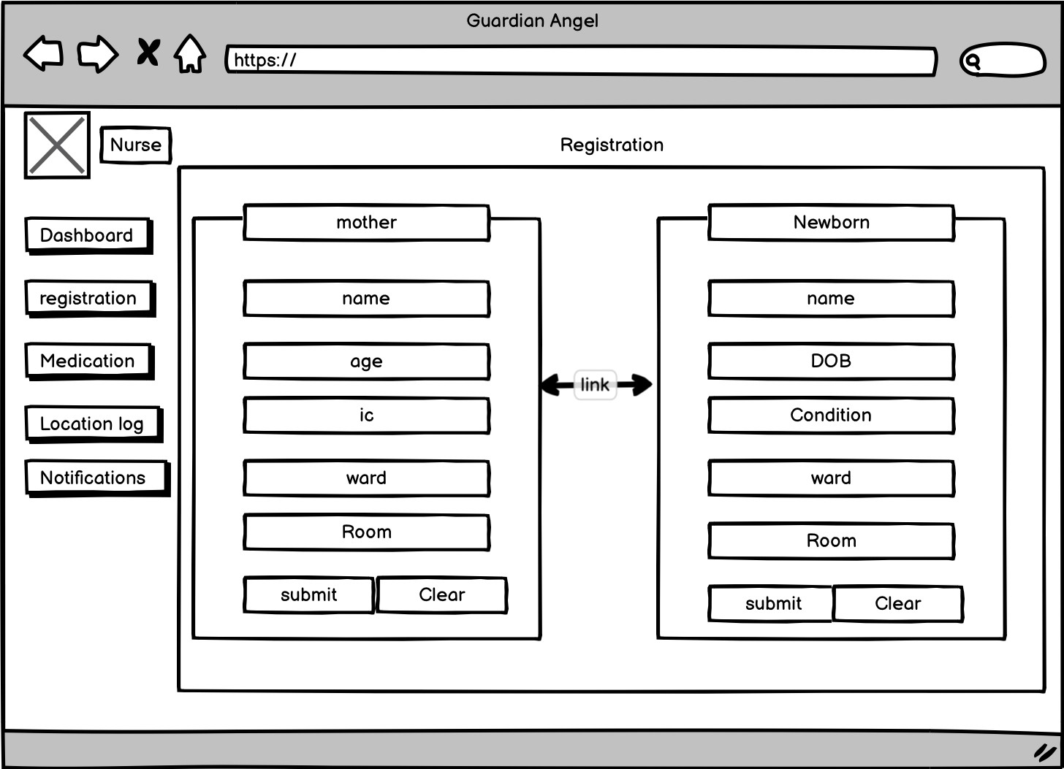

### Figure 4.13: registration page (mother and newborn) Page

This page allows medical personnel to register a mother's and newborn information into the system. It includes fields for entering personal details such as name, age, blood type, and contact information. The interface is designed to ensure that all necessary data is captured accurately and efficiently.

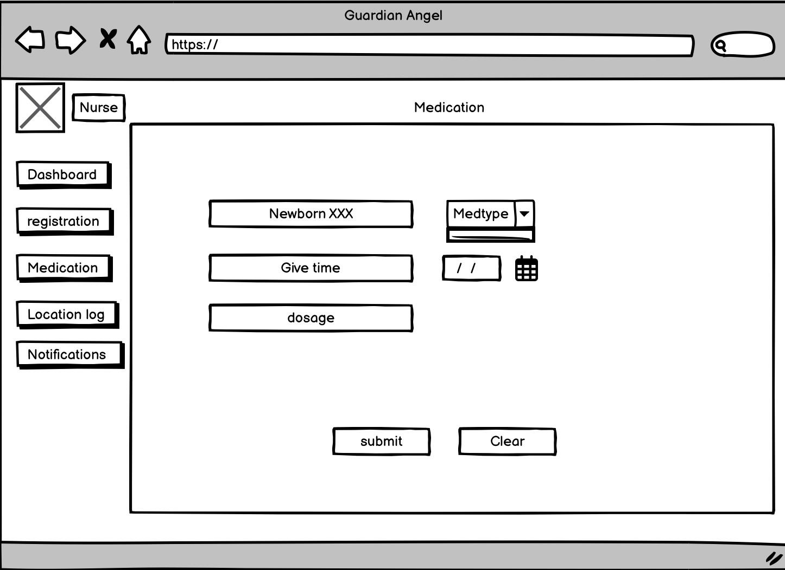

### Figure 4.13: Medication Administration Page

The medication entry page is used by medical personnel to input and update medication details for infants. The interface includes fields for the medication name, dosage, schedule time, and administration details. This ensures precise record- keeping and helps in maintaining accurate medication schedules for each infant.

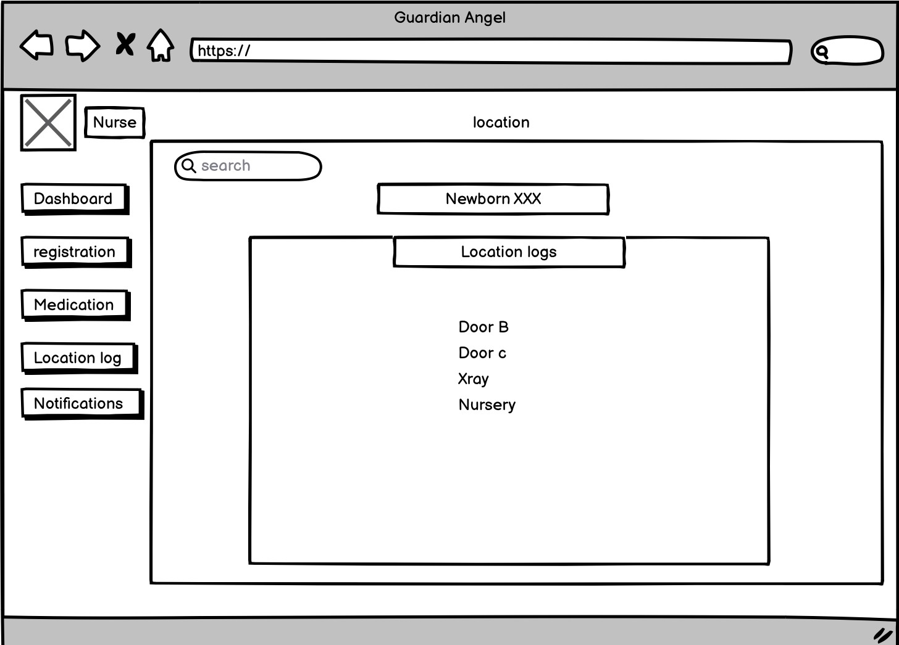

### Figure 4.13: Track Location Page

The track log page records and displays the movements of infants within the hospital. It provides a detailed log of location data, ensuring that medical personnel can monitor the movements of each infant accurately. The interface is designed to facilitate easy navigation and retrieval of historical movement data.

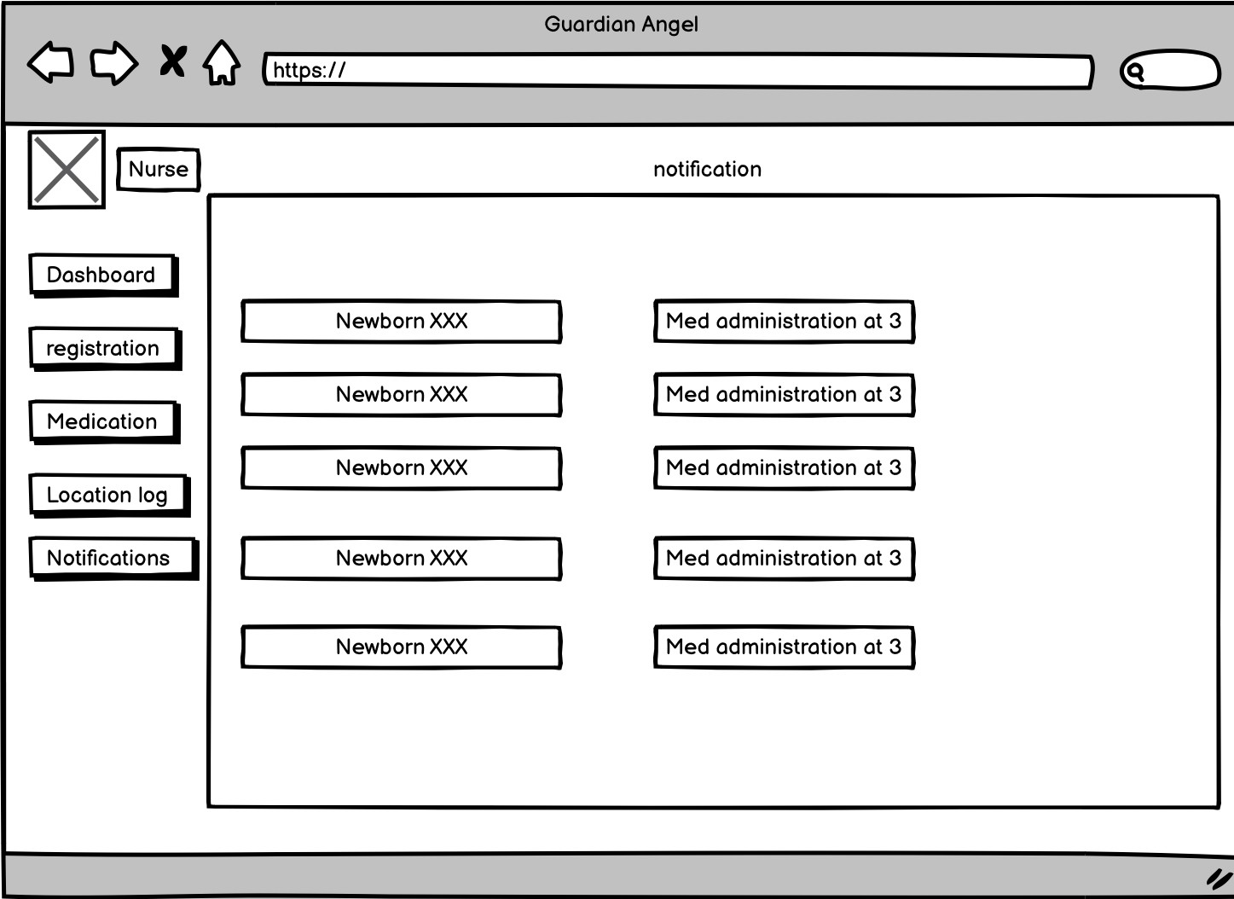

### Figure 4.13: Notification Page

This page displays alerts generated by the system when specific conditions are met, such as an infant exiting a designated area. It provides real-time notifications to medical personnel, ensuring immediate attention to potential security or health issues. The design includes clear and visible alert messages to prevent any oversight.

# CHAPTER 5

# IMPLEMENTATION

### Introduction

This chapter describes the system analysis and design procedures used in the creation of an RFID-based newborn care system. The goal is to provide a thorough understanding of how the system requirements were obtained and how the system was created to meet them. The chapter is organised into numerous sections, beginning with the methods for eliciting requirements and progressing to the detailed system design, which includes several diagrams and data descriptions. The final section discusses the design of the user interface, which ensures that the system is both functional and usable. This organised method ensures that all components of the system are thoroughly analysed and efficiently created to satisfy the users' requirements.

# REFERENCES

ASHP Foundation. (2022). Advancing Medication Safety Through Technology Innovations: Focus on Radio-Frequency Identification Technology. American Society of Health-System Pharmacists. Retrieved from https://[www.ashpfoundation.org](http://www.ashpfoundation.org/)

Eddy, N. (2023, April 3). How RFID in healthcare transforms point of care. HealthTech Magazine. Retrieved from https://healthtechmagazine.net/article/2023/04/how-rfid-and-mobile-tech- transform-point-care

RFID Journal. (2021, August 13). Current RFID Trends and Challenges You Should Know About. RFID Journal. Retrieved from [http://www.rfidjournal.com](http://www.rfidjournal.com/)

Profetto, L., Gherardelli, M., & Iadanza, E. (2022). Radio Frequency Identification (RFID) in health care: where are we? A scoping review. Health and Technology, 12(879-891). https://doi.org/10.1007/s12553-022-00696-1

Wong, W. (2021). How RFID solutions improve patient safety and hospital workflow. HealthTech Magazine. Retrieved from https://healthtechmagazine.net/article/2021/01/how-rfid-solutions-improve- patient-safety-and-hospital-workflow

Ann & Robert H. Lurie Children’s Hospital of Chicago. (2020). Improved wireless sensors to monitor babies in neonatal intensive care. Retrieved from https://[www.luriechildrens.org/en/news-stories/improved-wireless-sensors-](http://www.luriechildrens.org/en/news-stories/improved-wireless-sensors-) to-monitor-babies-in-neonatal-intensive-care/

GreenM.io. (2020). RFID Technology in Healthcare: Benefits, Challenges, Opportunities. Retrieved from https://greenm.io/rfid-technology-in- healthcare/

Mulac, A., Mathiesen, L., Taxis, K., & Gerd Granås, A. (2021). Barcode medication administration technology use in hospital practice: a mixed-methods observational study of policy deviations. BMJ Quality & Safety, 30(12), 1021– 1030. https://doi.org/10.1136/bmjqs-2021-013223

Buhagiar, E., & De Raffaele, C. (2021). Effectiveness of a Biometric Patient Identification System. eTELEMED 2021. Retrieved from https://academia.edu/50825516/Effectiveness_of_a_Biometric_Patient_Iden tification_System

Dhaka, G. (2021). Research Study on RFID and its Future Applications. International Journal for Research in Applied Science & Engineering Technology (IJRASET). Retrieved from https://[www.ijraset.com/fileserve.php?FID=33277](http://www.ijraset.com/fileserve.php?FID=33277)

Identifying the Potential of RFID in Disaster Healthcare: An International Delphi Study. (2021). Electronics, 10(21), 2621.

https://doi.org/10.3390/electronics10212621

Privacy-Aware Architectures for NFC and RFID Sensors in Healthcare Applications. (2022). Sensors, 22(24), 9692. https://doi.org/10.3390/s22249692

Bowen, G. A. (2009). Document analysis as a qualitative research method. Qualitative Research Journal, 9(2), 27-40.

https://doi.org/10.3316/QRJ0902027

Chia, L. C. (n.d.). Hospital inpatient tracking system using RFID technology.

Bachelor's thesis.

Kumar, S., Swanson, E., & Tran, T. (2020). RFID technology in healthcare: Benefits, challenges, opportunities. Journal of Healthcare Technology, 14(3), 187-200.

RFID-enabled healthcare applications, issues and benefits: An archival analysis (1997–2011). (2011). Journal of Healthcare Management, 16(1), 45-67.

Improved wireless sensors to monitor babies in neonatal intensive care. (n.d.).

Journal of Neonatal Care, 11(2), 75-89.

Wang, J., Chao, H., & Liu, Y. (2011). A remote baby surveillance system with RFID and GPS tracking. International Journal of Advanced Computer Science and Applications, 2(7), 45-52.

Applying RFID systems to improve the correctness of newborn identity reconfirmation. (n.d.). Healthcare Technology Review, 22(5), 34-47.

# APPENDICES

### Appendix A : Project Gantt Chart

|  |  |  |  |  |  |  |
| --- | --- | --- | --- | --- | --- | --- |
|  |  | Name | Duration | Start | Finish | Predecessors |
| 1 |  | Iteration 1: Establishing the Foundation | 1 day? | 5/1/24 8:00 AM | 5/1/24 5:00 PM |  |
| 2 |  | 1.1 Planning and Setup | 10 days? | 5/1/24 8:00 AM | 5/14/24 5:00 PM |  |
| 3 |  | - Requirement Gathering | 10 days? | 5/1/24 8:00 AM | 5/14/24 5:00 PM |  |
| 4 |  | 1.2 Initial Design | 10 days? | 5/15/24 8:00 AM | 5/28/24 5:00 PM |  |
| 5 |  | -Basic System Architecture | 5 days? | 5/15/24 8:00 AM | 5/21/24 5:00 PM | 1 |
| 6 |  | Initial UI/UX Desing | 5 days? | 5/22/24 8:00 AM | 5/28/24 5:00 PM |  |
| 7 |  | 1.3 Prototype Implementation | 15 days? | 5/29/24 8:00 AM | 6/18/24 5:00 PM |  |
| 8 |  | -Hardware Prototype | 10 days? | 5/29/24 8:00 AM | 6/11/24 5:00 PM |  |
| 9 |  | -Basic Web Dashboard | 5 days? | 6/12/24 8:00 AM | 6/18/24 5:00 PM |  |
| 10 |  | 1.4 Evaluation and Feedback | 10 days? | 6/19/24 8:00 AM | 7/2/24 5:00 PM |  |
| 11 |  | -Initial Testing | 5 days? | 6/19/24 8:00 AM | 6/25/24 5:00 PM |  |
| 12 |  | -Collect Feedback | 5 days? | 6/26/24 8:00 AM | 7/2/24 5:00 PM |  |
| 13 |  | -Milestone:End of Iteration 1 | 1 day? | 7/2/24 8:00 AM | 7/2/24 5:00 PM |  |
|  |  |  |  |  |  |  |
| 15 |  | Iteration 2: Enhancement and Integration | 10 days? | 7/3/24 8:00 AM | 7/16/24 5:00 PM |  |
| 16 |  | 2.1 Revised Planning | 10 days? | 7/3/24 8:00 AM | 7/16/24 5:00 PM |  |
| 17 |  | -Review and Adjust Requirements | 10 days? | 7/3/24 8:00 AM | 7/16/24 5:00 PM |  |
| 18 |  | 2.2 Enhance Design | 10 days? | 7/17/24 8:00 AM | 7/30/24 5:00 PM |  |
| 19 |  | -Improved System Architecture | 5 days? | 7/17/24 8:00 AM | 7/23/24 5:00 PM |  |
| 20 |  | -Advance UI/UX Design | 5 days? | 7/24/24 8:00 AM | 7/30/24 5:00 PM |  |
| 21 |  | 2.3 Advance Implementation | 15 days? | 7/31/24 8:00 AM | 8/20/24 5:00 PM |  |
| 22 |  | -Enhanced Hardware Integration | 10 days? | 7/31/24 8:00 AM | 8/13/24 5:00 PM |  |
| 23 |  | -Expanded Web Dashboard Features | 5 days? | 8/14/24 8:00 AM | 8/20/24 5:00 PM |  |
| 24 |  | 2.4 Second Evaluation | 10 days? | 8/21/24 8:00 AM | 9/3/24 5:00 PM |  |
| 25 |  | -Iteration Testing | 5 days? | 8/21/24 8:00 AM | 8/27/24 5:00 PM |  |
| 26 |  | -Refine Based on Feedback | 5 days? | 8/28/24 8:00 AM | 9/3/24 5:00 PM |  |
| 27 |  | -Milestone: End of Iteration 2 | 1 day? | 9/3/24 8:00 AM | 9/3/24 5:00 PM |  |
|  |  |  |  |  |  |  |
| 29 |  | Iteration 3: Final Refinement and Preparation for Deployment | 10 days? | 9/4/24 8:00 AM | 9/17/24 5:00 PM |  |
| 30 |  | 3.1 Final Planning | 10 days? | 9/4/24 8:00 AM | 9/17/24 5:00 PM |  |
| 31 |  | - Final Requirement Review | 10 days? | 9/4/24 8:00 AM | 9/17/24 5:00 PM |  |
| 32 |  | -3.2 Final Design | 5 days? | 9/18/24 8:00 AM | 9/24/24 5:00 PM |  |
| 33 |  | -Final System Architecture | 5 days? | 9/18/24 8:00 AM | 9/24/24 5:00 PM |  |
| 34 |  | -Final UI/UX Refinement | 5 days? | 9/25/24 8:00 AM | 10/1/24 5:00 PM |  |

Guardian Angel gantt chart - page1

|  |  |  |  |  |  |  |
| --- | --- | --- | --- | --- | --- | --- |
|  |  | Name | Duration | Start | Finish | Predecessors |
| 35 |  | 3.3 Deployment Preparation | 10 days? | 10/2/24 8:00 AM | 10/15/24 5:00 PM |  |
| 36 |  | -System Integration and Testing | 10 days? | 10/2/24 8:00 AM | 10/15/24 5:00 PM |  |
| 37 |  | -Deploment Planning | 5 days? | 10/16/24 8:00 AM | 10/22/24 5:00 PM |  |
| 38 |  | 3.4 Final Evaluation and Deploment | 10 days? | 10/23/24 8:00 AM | 11/5/24 5:00 PM |  |
| 39 |  | -Final System Testing | 5 days? | 10/23/24 8:00 AM | 10/29/24 5:00 PM |  |
| 40 |  | -Deploment and Initial Monitoring | 5 days? | 10/30/24 8:00 AM | 11/5/24 5:00 PM |  |
| 41 |  | -Milestone:Deployed System | 1 day? | 11/5/24 8:00 AM | 11/5/24 5:00 PM |  |
|  | | | | | | |

Resource Names

28 Apr 24

5 May 24

12 May 24

19 May 24

26 May 24

2 Jun 24

9 Jun 24

16 Jun 24

23

S M T W T F S S M T W T F S S M T W T F S S M T W T F S S M T W T F S S M T W T F S S M T W T F S S M T W T F S S

Guardian Angel gantt chart - page2

n 24

30 Jun 24

7 Jul 24

14 Jul 24

21 Jul 24

28 Jul 24

4 Aug 24

11 Aug 24

18 Aug 24

25 Aug 24

W T F S S M T W T F S S M T W T F S S M T W T F S S M T W T F S S M T W T F S S M T W T F S S M T W T F S S M T W T F S S M T W T F

Guardian Angel gantt chart - page3

Sep 24

8 Sep 24

15 Sep 24

22 Sep 24

29 Sep 24

6 Oct 24

13 Oct 24

20 Oct 24

27 Oct 24

3 Nov 24

M T W T F S S M T W T F S S M T W T F S S M T W T F S S M T W T F S S M T W T F S S M T W T F S S M T W T F S S M T W T F S S M T W

Guardian Angel gantt chart - page9

### Appendix B : Declaration Form



UAHEPFKI/01/2023

|  |  |  |  |  |  |
| --- | --- | --- | --- | --- | --- |
|  | | | | **BORANG DEKLARASI (INDIVIDU) / *DECLARATION FORM* (*INDIVIDUAL*) UNTUK PENILAIAN MOD *ASYNCHRONOUS* / FOR ASYNCHRONOUS MODE ASSESSMENT** | |
| **A. MAKLUMAT PELAJAR/*STUDENT’S INFORMATION*** | | | | | |
| Nama Penuh / Full Name:  [Mengikut MyKad atau paspot / *As in MyKad or Passport* ] | | Carl Brandon Valentine | | | |
| No. Matrik / *Matric No*.: | | BI21160464 | | | |
| No. Telefon dan e-mel /  Phone No. and e-mail: | | 0168402837 [carl_brandon_valentine_bi21@iluv.ums.edu.my](mailto:carl_brandon_valentine_bi21@iluv.ums.edu.my) | | | |
| Nama Kursus / *Course Name*: | | Project 1 | | | |
| Kod Kursus / *Course Code*: | | KK34202 | | | |
| Jenis Penilaian / *Assessment Type* : | |  | Tugasan */ Assignment*  Kuiz / *Quiz*  Lain-lain / *Others* : (Nyatakan / *Specify*)  ………………………………………………… | | Latihan Makmal / *Lab Exercise*  Projek / *Project* |
| **B. DEKLARASI/ DECLARATION** | | | | | |
| **SILA BACA DENGAN TELITI SEBELUM MELENGKAPKAN BORANG INI/ *PLEASE READ CAREFULLY BEFORE COMPLETING THE FORM***   1. Saya dengan ini mengaku bahawa penilaian ini adalah hasil kerja saya sendiri sepenuhnya. Sebarang sumber maklumat tambahan, sama ada diterbitkan secara terbuka atau tidak diterbitkan, yang telah digunakan dan dirujuk dalam teks, senarai kandungan dan/atau senarai bibliografi telah diakui dengan sewajarnya dan semakan kesamaan melalui Turnitin adalah tidak melebihi 30%.   *I hereby declare that this assessment is entirely my own work. Any additional sources of information, whether publicly published or unpublished, that have been utilized and referenced within the text, contents list, and/or bibliographical list have been duly acknowledged and similarity check through Turnitin is not more than 30%*   1. Saya tidak akan membenarkan sesiapa menyalin atau mengeluarkan semula karya saya tanpa kebenaran saya dengan mengambil semua langkah berjaga-jaga.   *I will not allow anyone to copy or reproduce my work without my authorization by taking necessary precautions.*   1. Saya sedar dan memahami dasar Universiti mengenai plagiarisme dan amalan akademik yang baik. Saya sedar sepenuhnya bahawa sebarang pelanggaran dasar yang berkaitan akan mengakibatkan peruntukan sifar markah untuk penilaian ini dan mungkin akan mengakibatkan tindakan tatatertib.   *I am aware of and understand the University’s policy on plagiarism and good academic practices. I am fully aware that any vio lation of the relevant policies will result in the allocation of zero marks for this assessment and may also warrant disciplinary actions.*  Saya ada menggunakan *AI tools* dalam penyelesaian tugasan/ penilaian ini I have used AI tools in this assignment Assessment | | | | | |
| **C. PERAKUAN PELAJAR / *STUDENT DECLARATION*** | | | | | |
| No. K.P. / Paspot:  *I.C. no. / Passport:* | 000323-12-0091 |  |  | |  |
| Tandatangan Pelajar / *Signature of Student*: | | | Tarikh / *Date*: | | |
|  | | |

Nota/ Notes



1. Pelajar adalah digalakkan untuk melampirkan bersama laporan Turnitin (Kurang 30%) bersama borang ini tertakluk kepada permintaan pensyarah masing-masing.

Students are encouraged to attach their Turnitin reports (Less than 30%) with this form subject to the lecturer’s request.

### Appendix C : Meeting Log

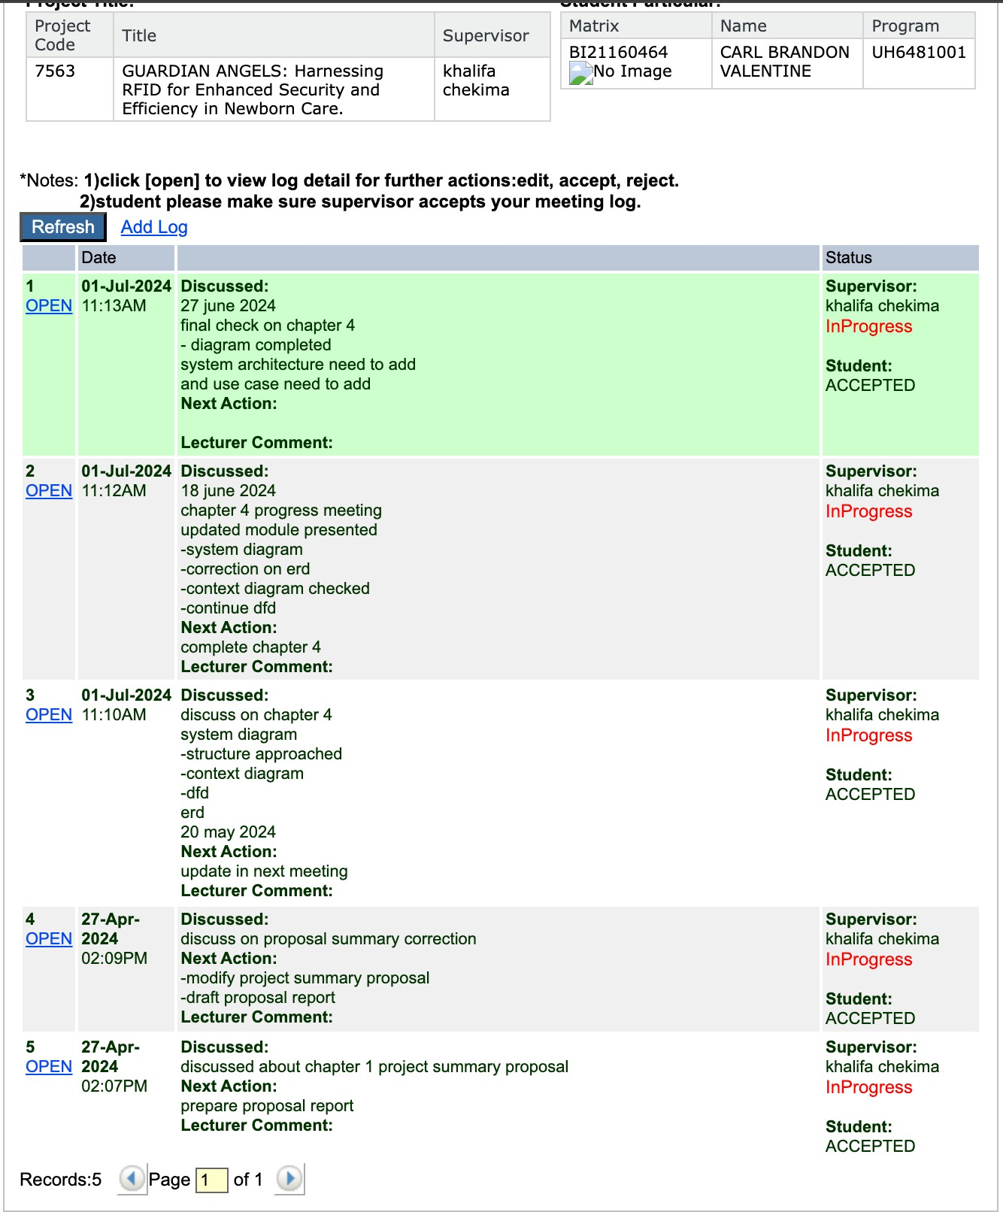

**Appendix D** : **Correction**

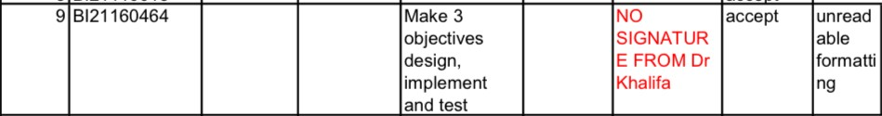

Correction:

Objectives:

* 1. Design a scalable RFID system prototype tailored for new born care, with a focus on a user-friendly interface.
  2. Implement the designed RFID system in a simulated hospital environment using Raspberry Pi Pico, RFID tags, and readers.
  3. Conduct comprehensive tests within the simulated environment to evaluate the RFID system's performance in new born identification and tracking.

### Appendix E : Questionnaires

